**MAKERERE UNIVERSITY**

**COLLEGE OF ENGINEERING DESIGN ART AND TECHNOLOGY**

**SCHOOL OF ENGINEERING**

**DEPARTMENT OF MECHANICAL ENGINEERING**

**INDUSTRIAL TRAINING DOCUMENTATION**

**AT**

**LUWEERO INDUSTRIES LIMITED**

**NAME: NAKATO KITIMBO ELSIE**

**SUPERVISER: DR. SAMUEL OKODI**

**ENG. BENJAMIN MUGISHA**

**PROJECT NAME: ELECTRIC FENCE**

**DESIGN OF THE CIRCUIT BOARD**

**FROM**

**JUNE-AUGUST**

**CIRCUIT BOARD DEISGN FOR AN ELECTRIC FENCE ENERGIZER**

**Planning the project**

**Literature review of the project**

**PROBLEM STATEMENT**

Security is very important in each locality especially in these times where cases of burglary and

Increasing un serious farmers have risen off the charts. Though it is the duty of the people or farmers in our country to ensure their animals are in one place, it is also one’s duty to cater and make sure that his/her home or farm is safe from such un wanted animals. This project will guide users and developers through building a security system that isn’t complex as but will do the job.

**HOW IT WORKS.**

An electric fence is made up of an open electrical circuit comprising of two arms as shown

Below:

1. The first arm is the fence connected to the fence energizer. This section is usually

Insulated from any other conductive material like the ground, leaves, grass and trees by

Plastic insulators or an air gap of at least 3cm.

2. The second arm is the ground itself that is connected to the Earth terminal of the

Energizer by way of a metal rod or earth stake/post.

This forms OPEN electrical circuit as shown below waiting for a person or animal to complete the Circuit.



The voltage being sent through the wires is usually very high but the current or amperage is low.

Electric fence energizers output high voltages of around **8kV** but very low amperage around

**120mA**. Also the output is made safe in that the electrical energy is released in pulses once every

1/300th second. The reason for the pulsating current is that if the wires are touched and deliver

Shock, then whatever touches it has a chance to withdraw. The person or animal has to be in direct contact with the ground to feel the shocking sensation. This is why a Bird resting on the wire will not receive a shock since it is not touching the ground so the circuit isn’t completed. Another case is when a person wearing insulated footwear will only receive a

very small shock because all the current cannot pass through the insulated soles as shown above.

**Schematic diagram for the circuit board**

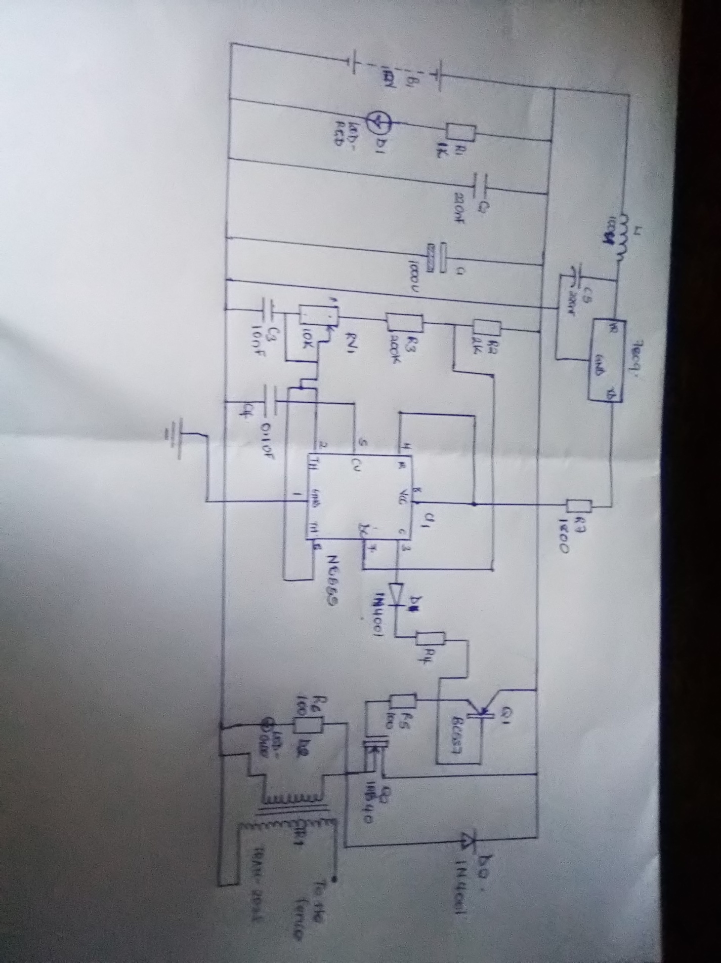

**Integrated circuit (NE555)**

Pin 1: Grounded Terminal: All the voltages are measured with respect to the Ground terminal.

Pin 2: Trigger Terminal: The trigger pin is used to feed the trigger input, and then the 555 IC is set up astable timer. This pin is an inverting input of a comparator and is responsible

for the transition of flip-flop from set to reset. The output of the timer depends on the amplitude

of the external trigger pulse applied to this pin. A negative pulse with a dc level greater than

Vcc/3 is applied to this terminal.

.

Pin 3: Output Terminal: Output of the timer is available at this pin.

Pin 4: Reset Terminal: Whenever the timer IC is to be reset or disabled, a negative pulse is

applied to pin 4, and thus is named as reset terminal. The output is reset irrespective of the input

condition. When this pin is not to be used for reset purpose, it should be connected to + VCC to

avoid any possibility of false triggering.

Pin 5: Control Voltage Terminal: The threshold and trigger levels are controlled using this pin.

The pulse width of the output waveform is determined by connecting a POT or bringing in an

external voltage to this pin. The external voltage applied to this pin can also be used to modulate

the output waveform. Thus, the amount of voltage applied in this terminal will decide when the

comparator is to be switched, and thus changes the pulse width of the output. When this pin is

not used, it should be bypassed to ground through a 0.01 micro Farad to avoid any noise

Pin 6: Threshold Terminal: This is the non-inverting input terminal of comparator 1, which

Compares the voltage applied to the terminal with a reference voltage of 2/3 VCC. The amplitude of voltage applied to this terminal is responsible for the set state of flip-flop. When the voltage applied in this terminal is greater than 2/3Vcc, the upper comparator switches to +Vsat and the output gets reset.

Pin 7: Discharge Terminal: This pin is connected internally to the collector of transistor and mostly a capacitor is connected between this terminal and ground. It is called discharge terminal

because when transistor saturates, capacitor discharges through the transistor. When the

transistor is cut-off, the capacitor charges at a rate determined by the external resistor and

capacitor.

Pin 8: Supply Terminal: A supply voltage of + 5 V to + 15V is applied to this terminal with

respect to ground (pin 1).

**ASTABLE MODE OF THE TIMER**

Here pins 2 and 6 are connected so the circuit will trigger itself each timing cycle, thereby

functioning as an oscillator. Capacitor C charges through R2 and R3 but discharges through R2.

The oscillator frequency is given by:

F= $1.44÷\left(R2+2R3\right)C$



**2.4.2 Pulse Width Modulation**

The NE555 timer helps us generate OFF/LOW/9V outputs termed as duty cycle or square wave.

The duration of the ON time is what is known as pulse-width and when the width pulse is varied

rapidly to generate an effect of what seems as an voltage signal, then the output is termed as PWM signal. For the case of generation of shock we require a 20% duty cycle shown below which can be generated from the integrated circuit in the astabe mode.

**25% duty cycle**



# Getting started with Proteus software

1. Designing a schematic diagram
2. Designing a Printed Circuit Board
3. Generating a 3-D print of the circuit boards

**1. Opening the Software icon**

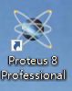

Double click on the software icon on your computer to open the software.

Then click on file to create new project

Then move to new project as shown below and click on it to open a new project and continue by clicking next until the finish icon as shown in the proceeding pictures.

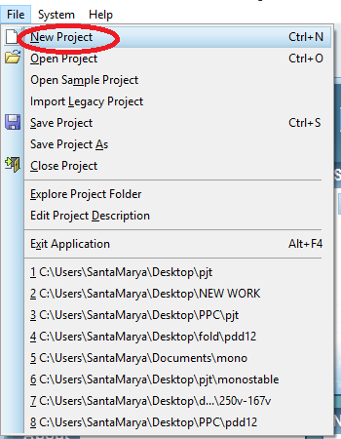

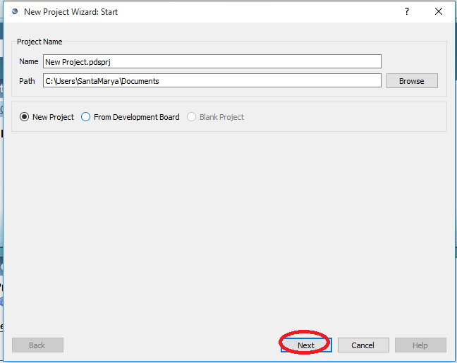

To proceed, click next for the next steps until to get to the finish icon as shown below

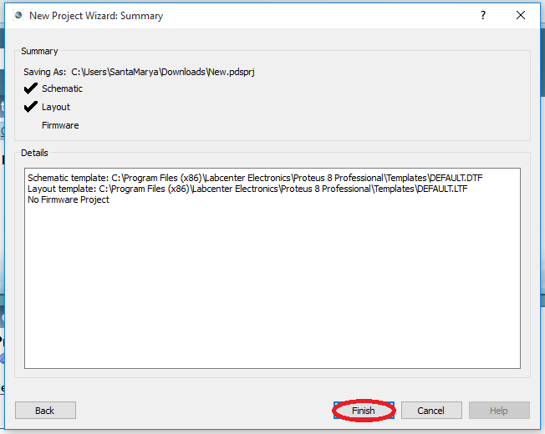

**2.Starting the schematic diagram.**

To start the schematic move to system as shown so that you can be able to set sheet sizes as you require them. Move to set sheet sizes as shown in the red arrow and after that the screen should display a blue box as shown in the print screen.

.

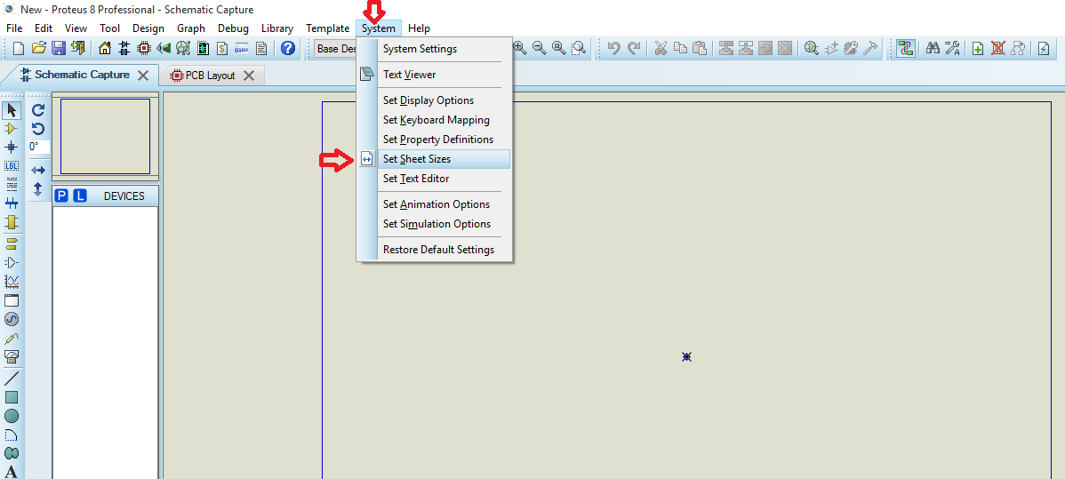

The table below will appear and you select A4 sheet layout as shown and proceed to click okay.

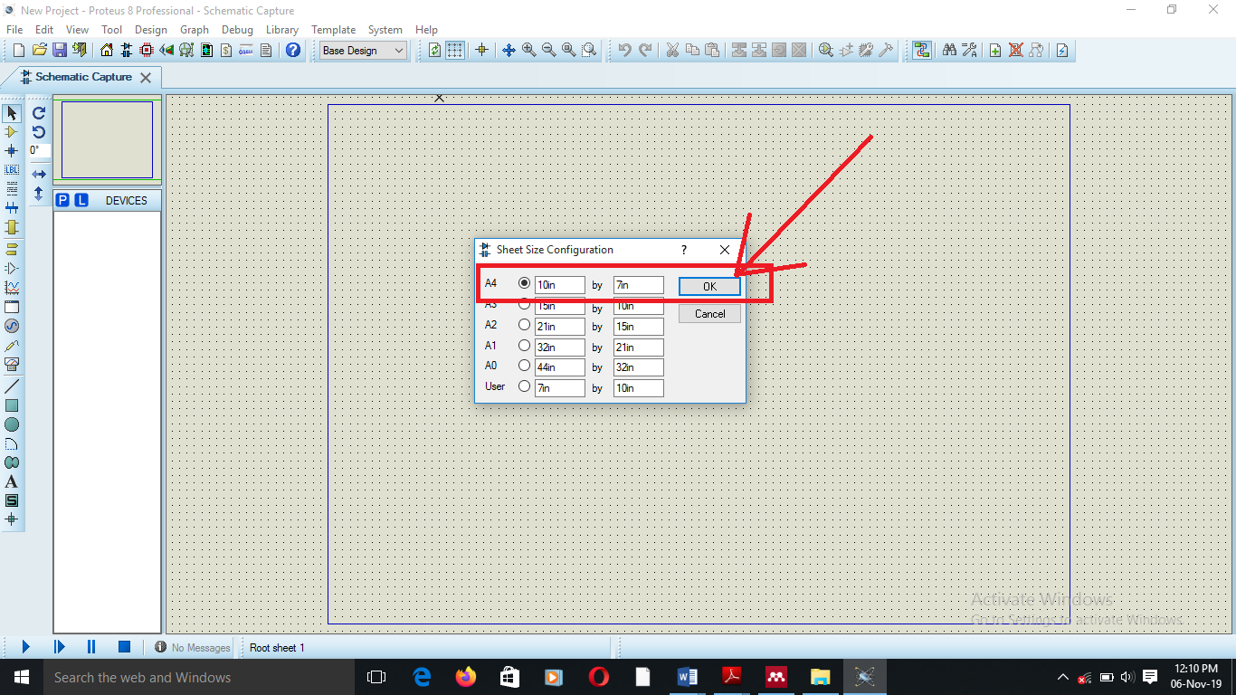

1. **Saving the project.**

Move to file as highlighted in the red arrow and click in save as to have your project saved as you required it in the names you can clearly remember each time you will want to open it.

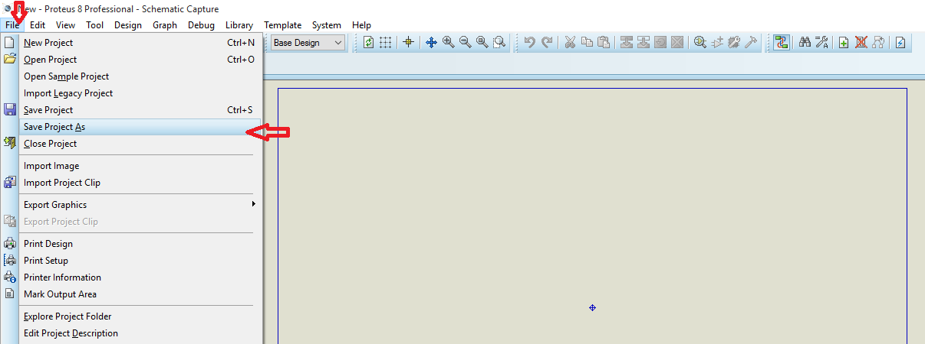

Save the project as an electric fence energizer on the desktop

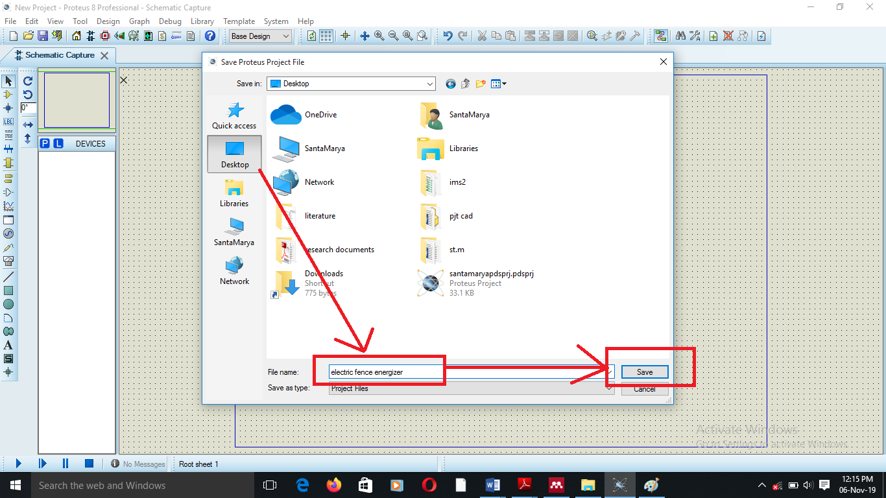

From the schematic diagram on our paper with the components, with shall have to transfer the same information on paper and produce a schematic diagram in this software which we can then run the simulations and do our analysis as we require it.

### **Inputting Components**

A component is an instant device, picked from one of the device libraries. Since some devices are multi-element it follows that in some cases, several components on the schematic may in fact all belong to one physical component on the PCB.

Apart from physical terminals, components are only objects you can place which will generate physical entities in the PCB design.

We shall replicate the components and the schematic we have on paper to the software but we start with the components and putting the wire later.



**Selecting components from the Device Libraries**

1. Ensure that the object selector is showing devices by selecting the components icon from the mode selector toolbar.
2. Click on the **P** button on the object selector. This will cause the Device Library Pick Form to appear.

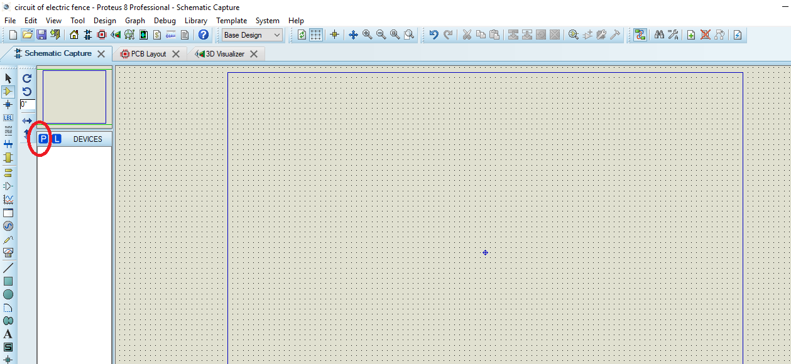

The screen shown below should appear after clicking icon **P**, then move to the keywords search box shown in red box from which you will type the component required.

1. The screen shown below should appear after clicking icon**P**, then move to the keywords search box shown in red box from which you will type the component required.
2. In the library selector, select the library you wish to pick devices from. The objects selector is updated to show the contents of the library according to the settings of the extensions selector. Where the extensions selector is hidden, all library parts will be shown.
3. Where the prefixes selector is shown select the correct prefix for the part you require. You can type the name of the components you require for example battery and then click on it in the other highlighted box to select the one you will require and then click okay as shown in the next print screen.
4. Single click a part in the object selector to browse the part in the browser window double click a part in the objects selector to it in the design.

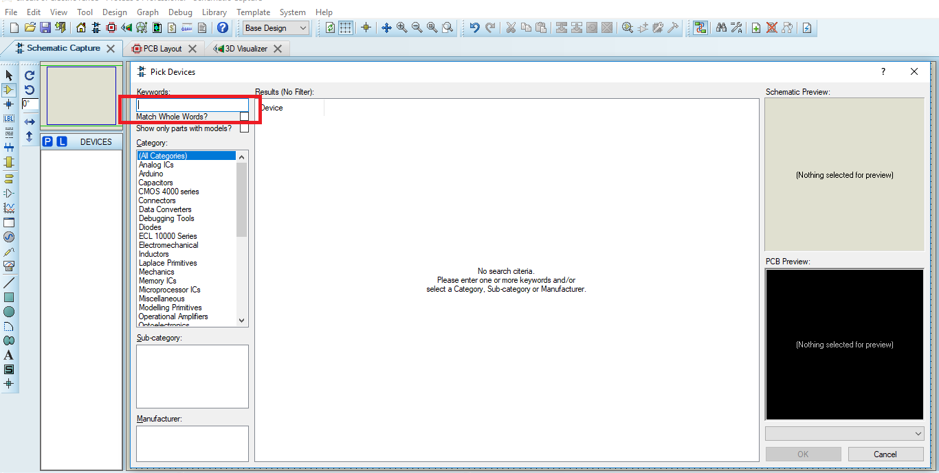

You can type the name of the components you require for example battery and then click on it in the other highlighted box to select the one you will require and then click okay as shown in the next print screen.

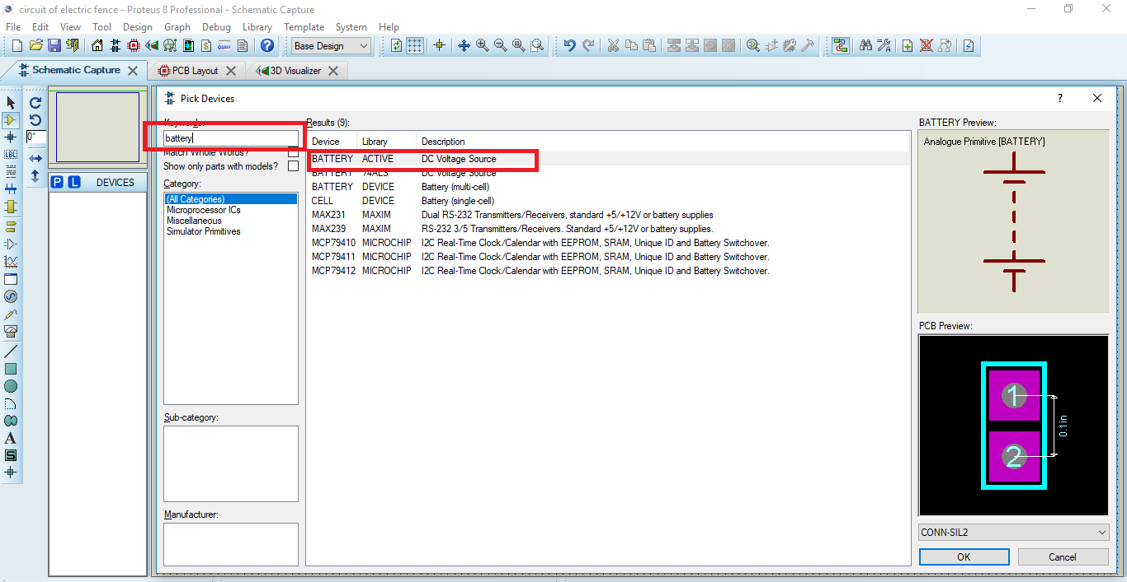

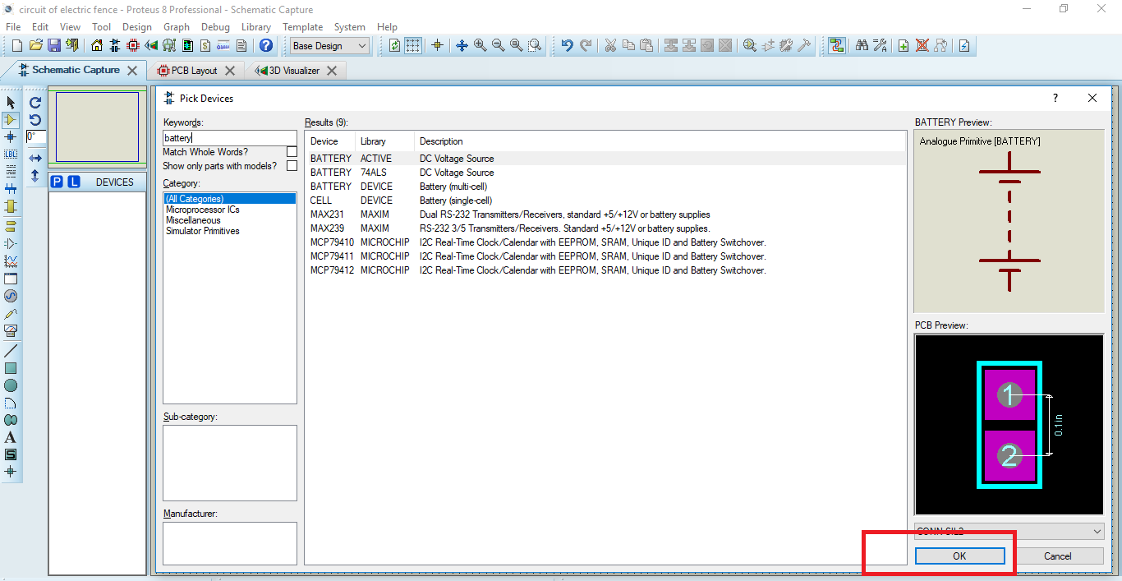

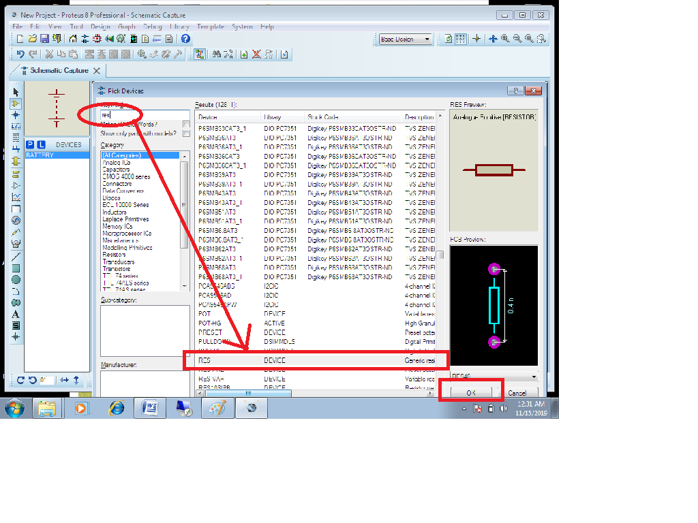

Do the same for all the components and devices you will require and click okay. These components should then appear in the dialog box for devices a shown in the print screen below.

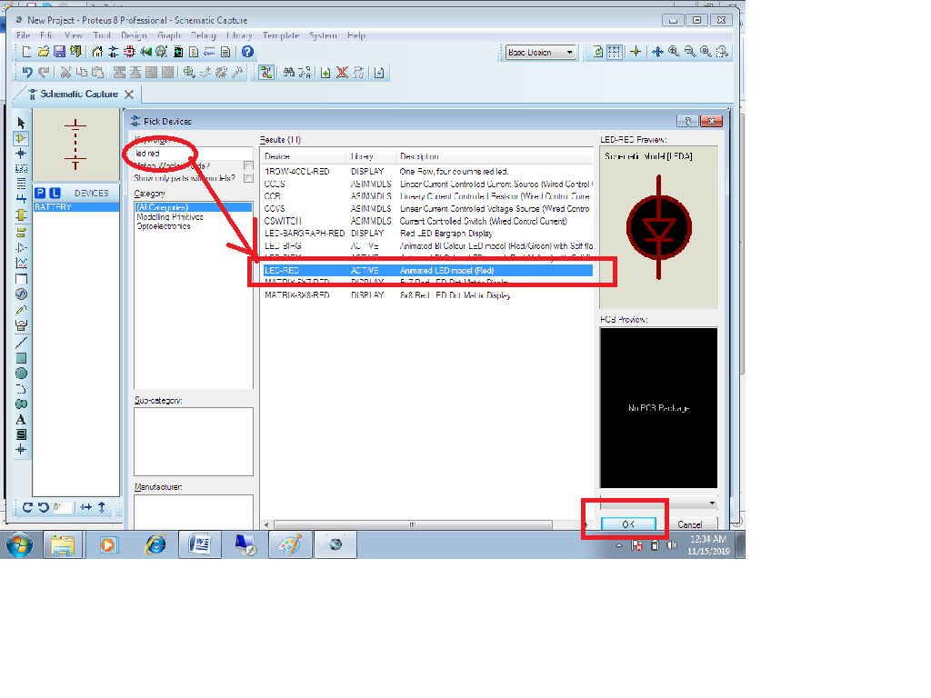

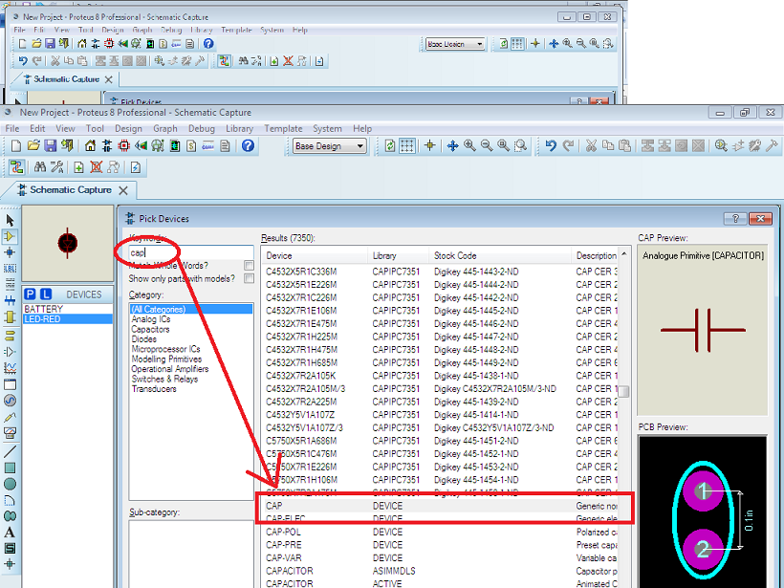

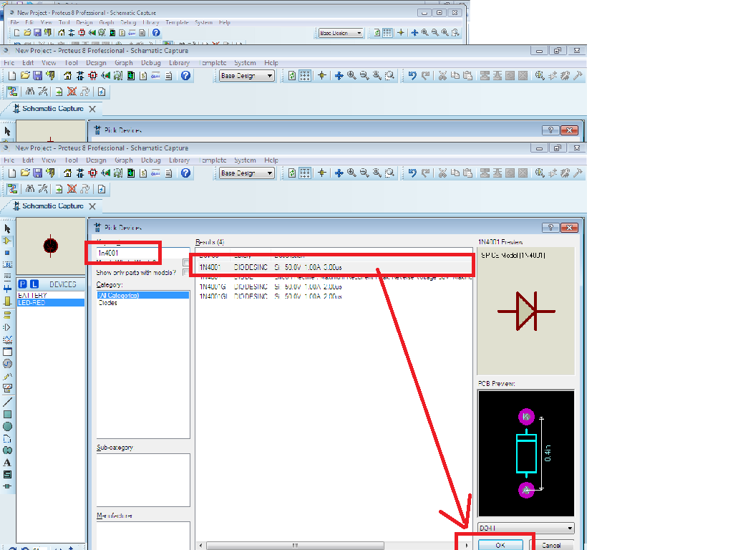

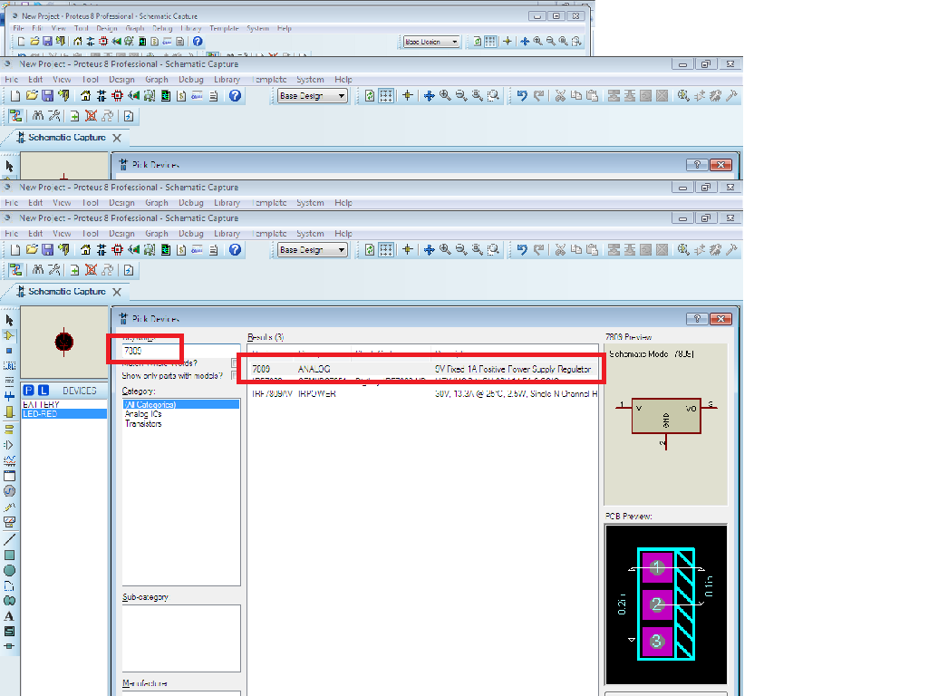

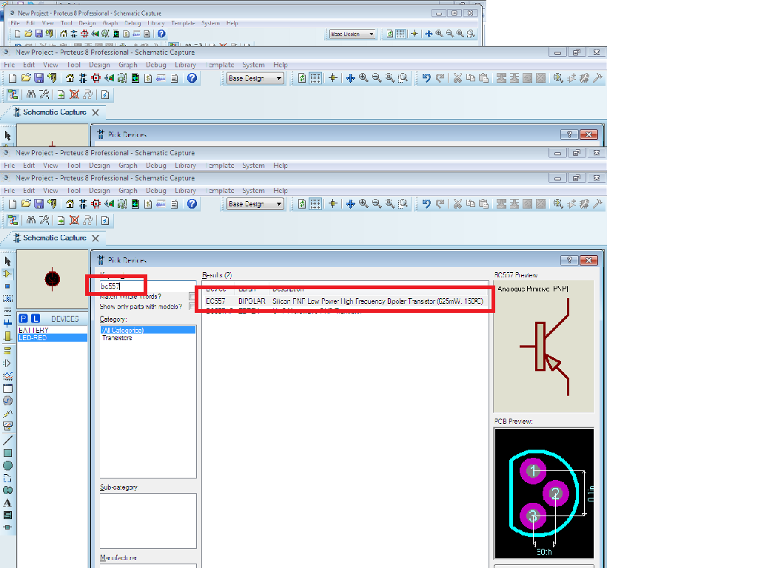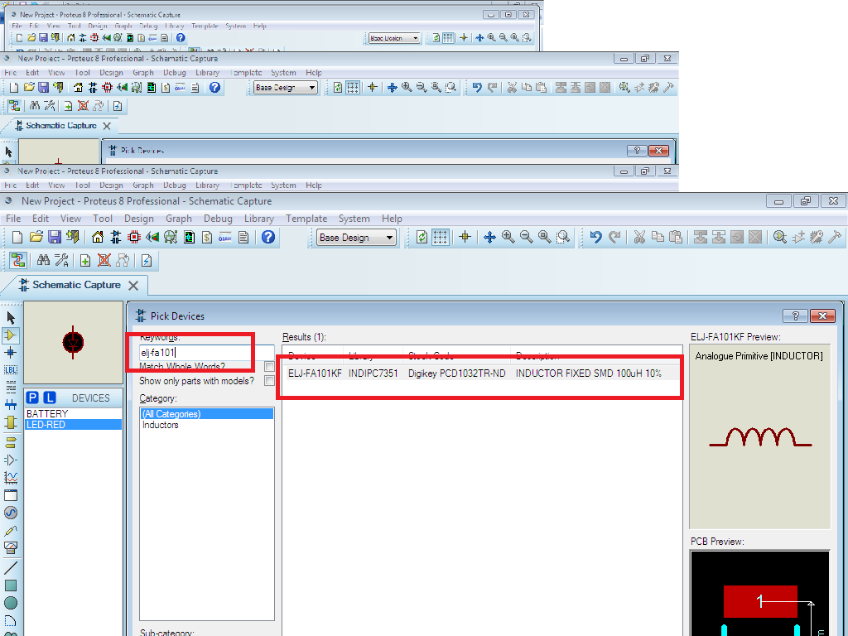

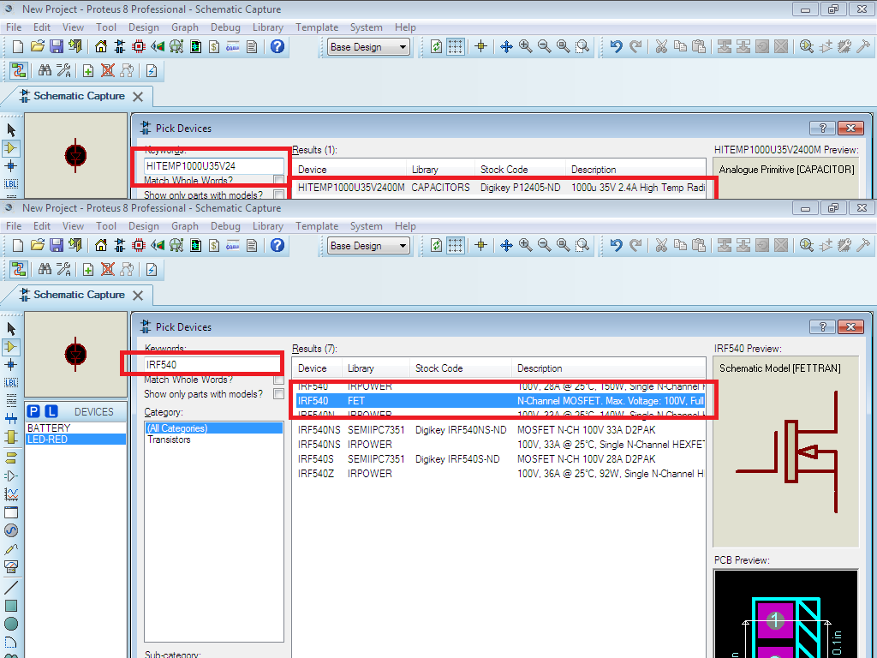

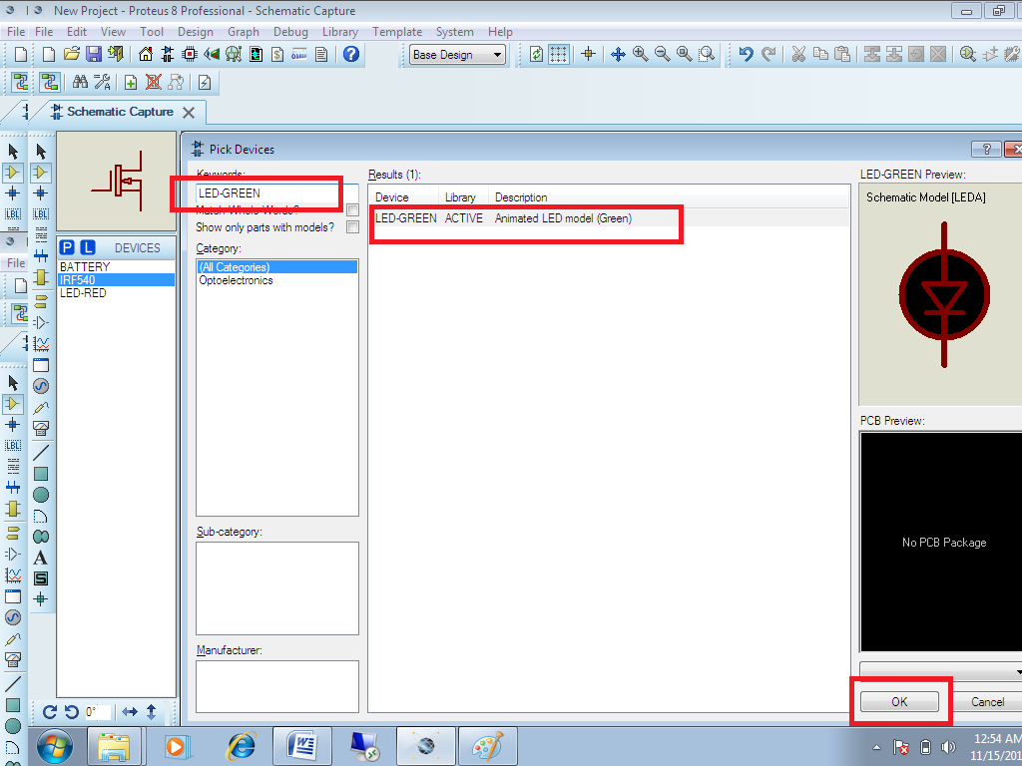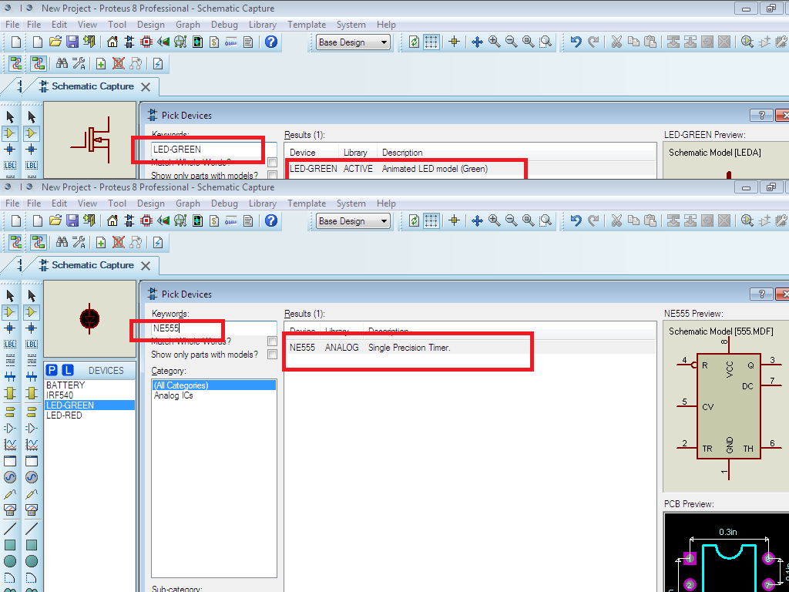

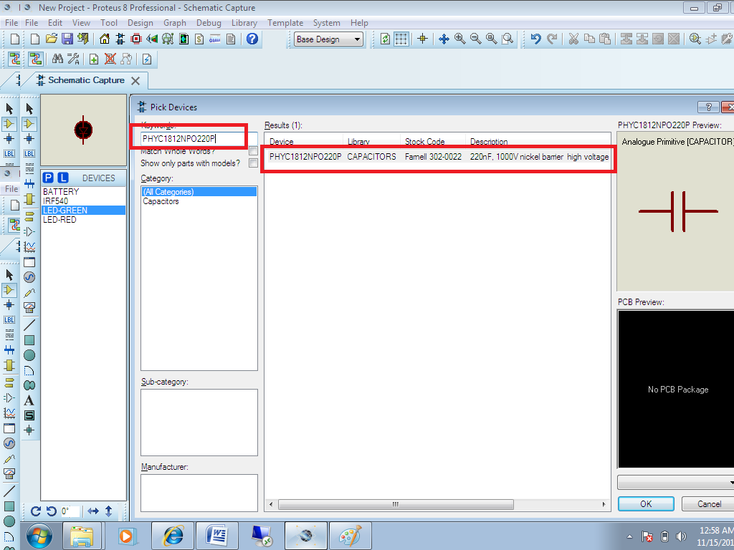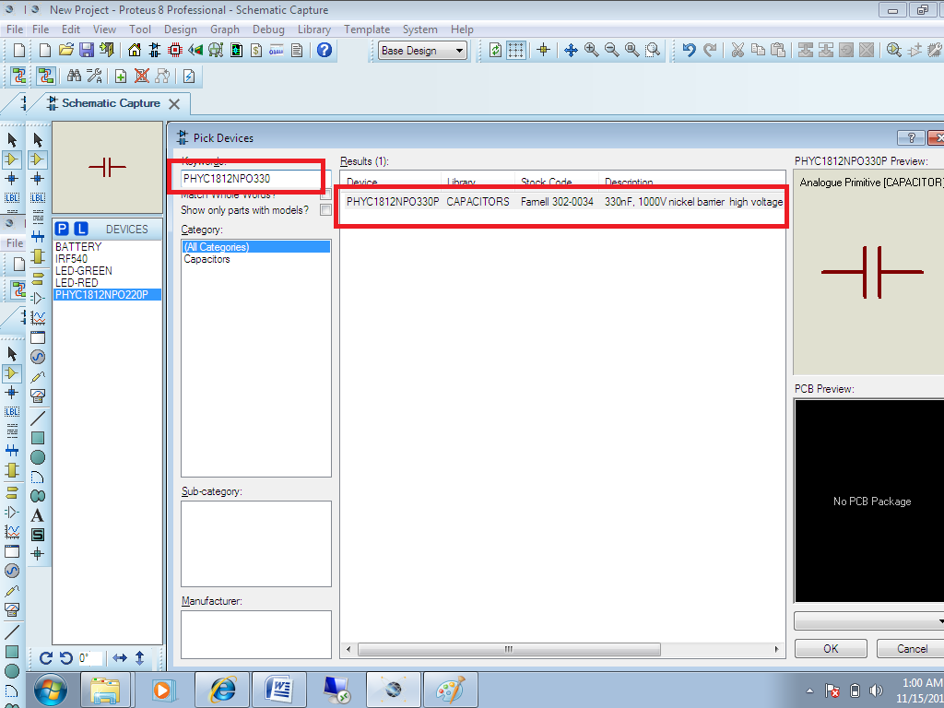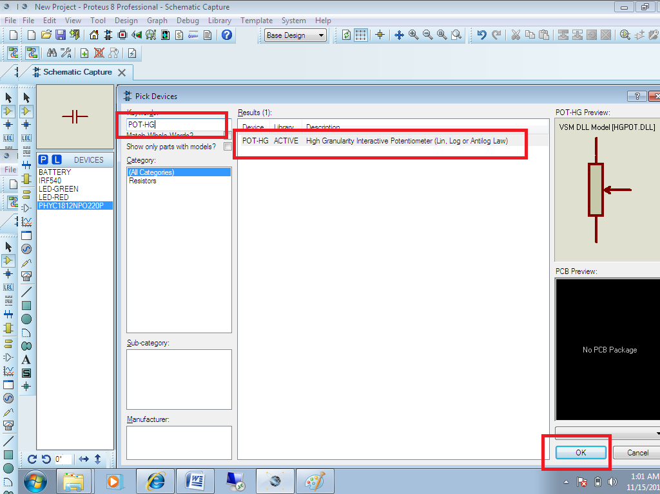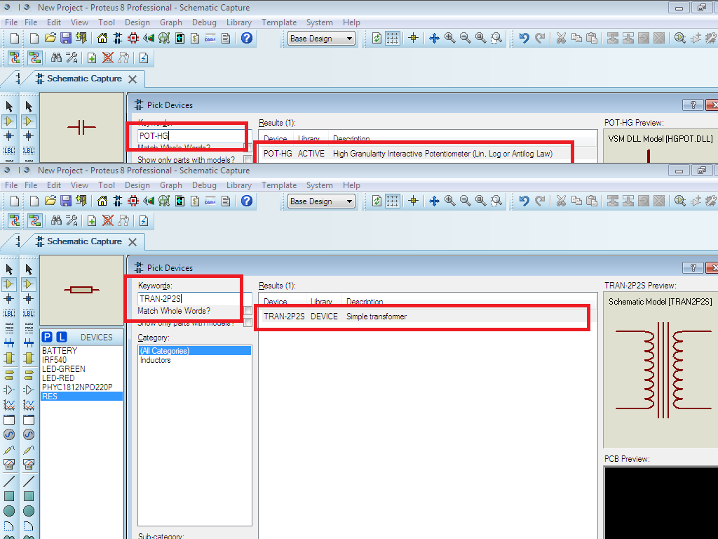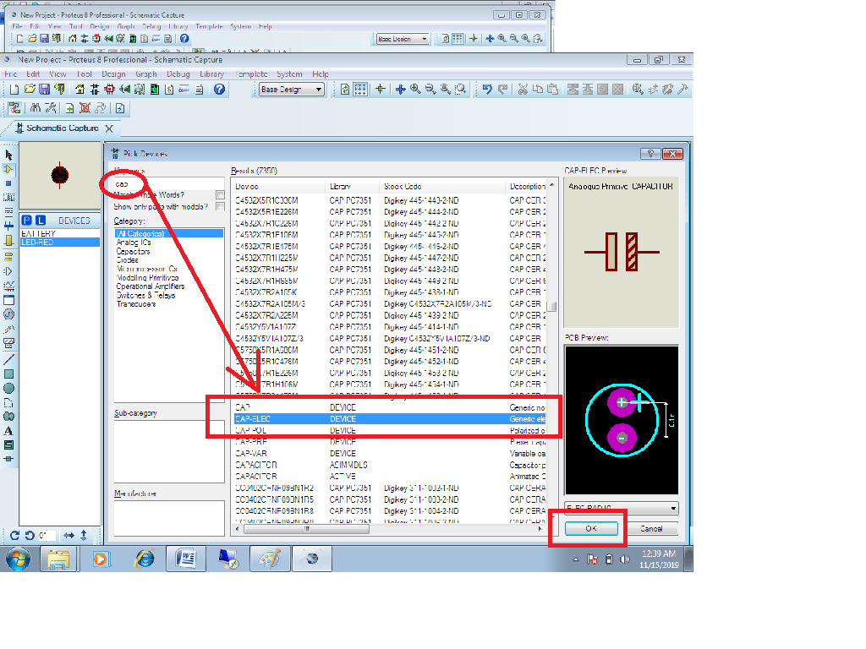

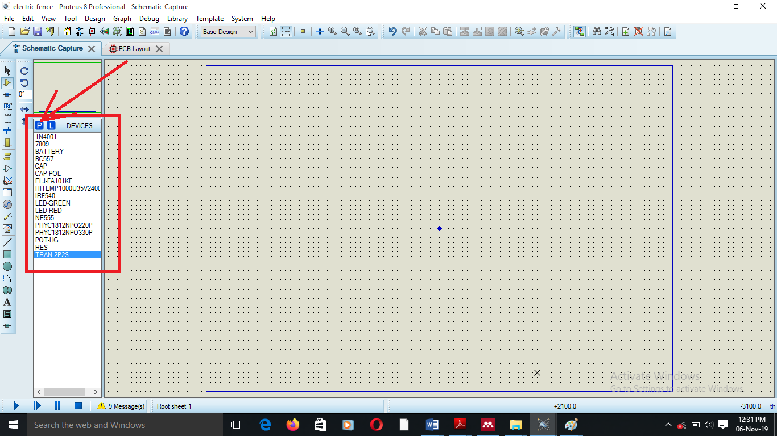

#### **Placing the components**

1. If the device type you want is not listed as shown in the above print screen of the object selector, first pick it from the libraries as described in the previous section.
2. Highlight the device name in the object selector.
3. Use the rotation and mirror icons to orient the device according to how you want to place it.
4. Point at the position in the editing window where you want the device to appear and left click. If you hold the mouse button down, you can drag the device around until you have it exactly where you want it. When you release the mouse button, it will be placed onto the drawing.

We can then have our components taken to our board layout in the blue square box by clicking on the component in the dialog box for the devices shown above and then dragging them to the board layout.

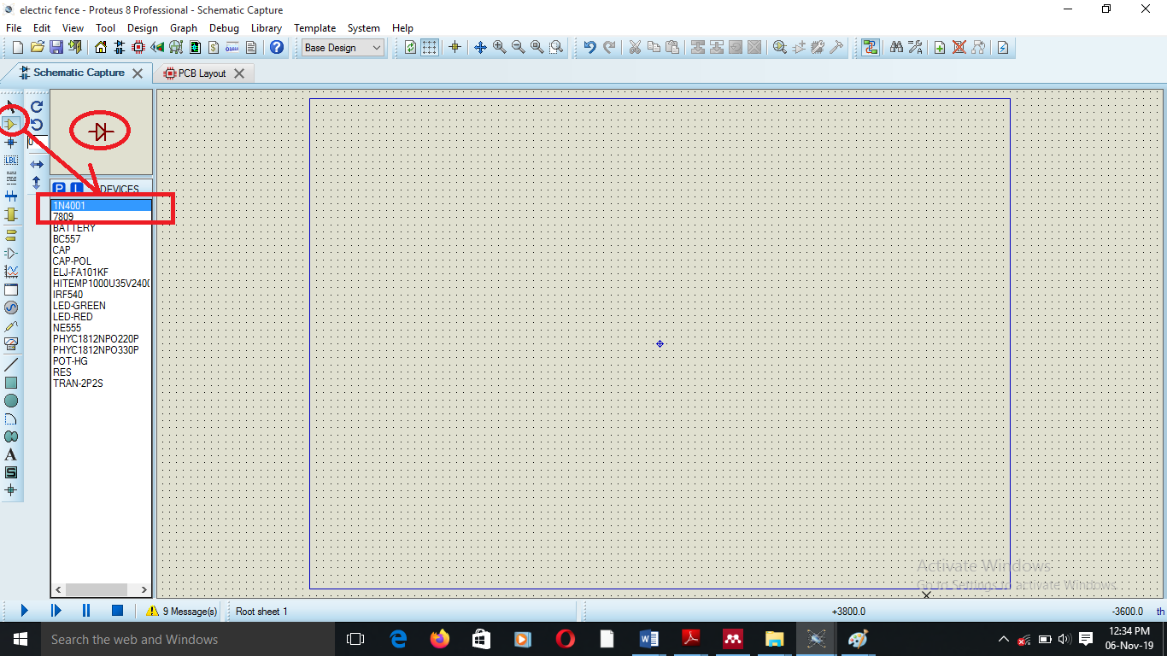

Since deleting a component removes the wires attached to it, changing a component by deleting it and then placing a new one can be somewhat tedious.

### **Replacing components**

#### **To replace one component with another**

1. Pick the new device type and highlight its name in the object selector described above.
2. Use the rotational and mirror icons to orient the new device according to how you want to place it.
3. Position the mouse pointer inside the old component and then place the new one such that at least one of its pin ends touches one of the pin ends of the component.

#### **Editing components**

A component may be edited using any of the general editing techniques and also specifically by using the edit component command on the edit menu for example as we were selecting the component for the resistors we selected only one with different parameters or specifications so we can edit the properties to what we shall require as follows and do the same to other components that might require editing.

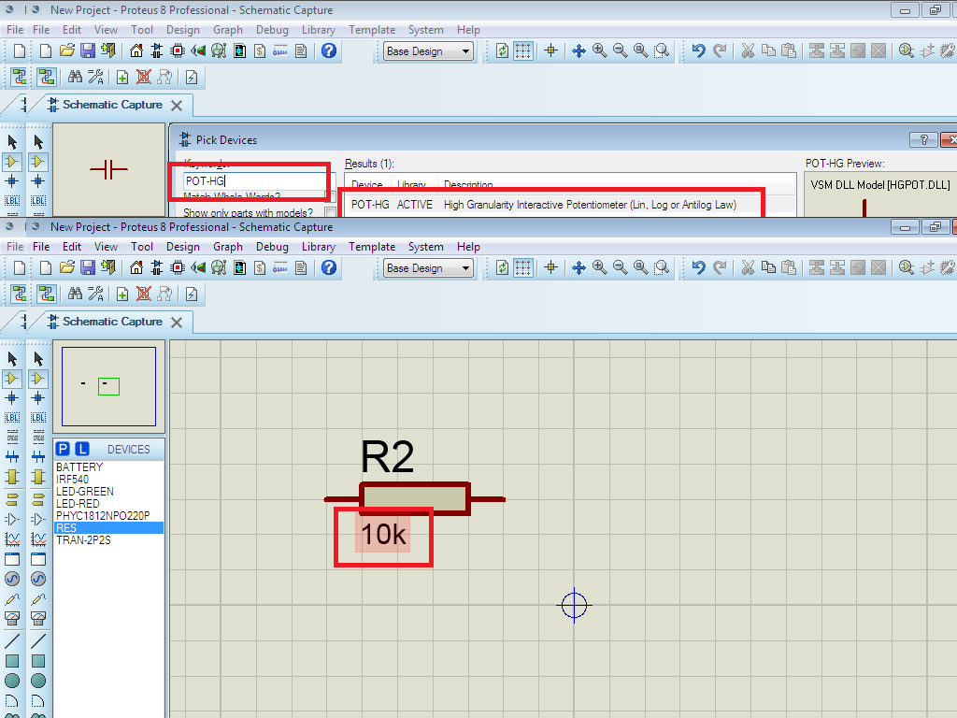

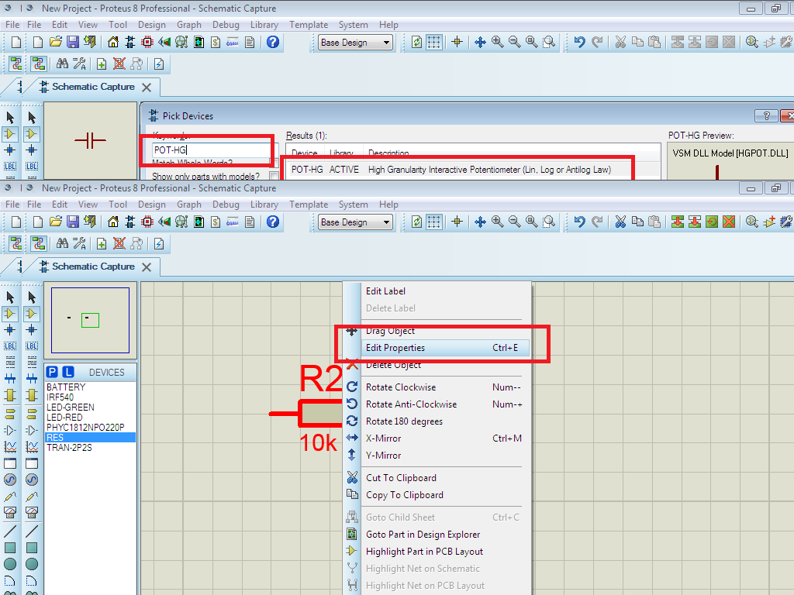

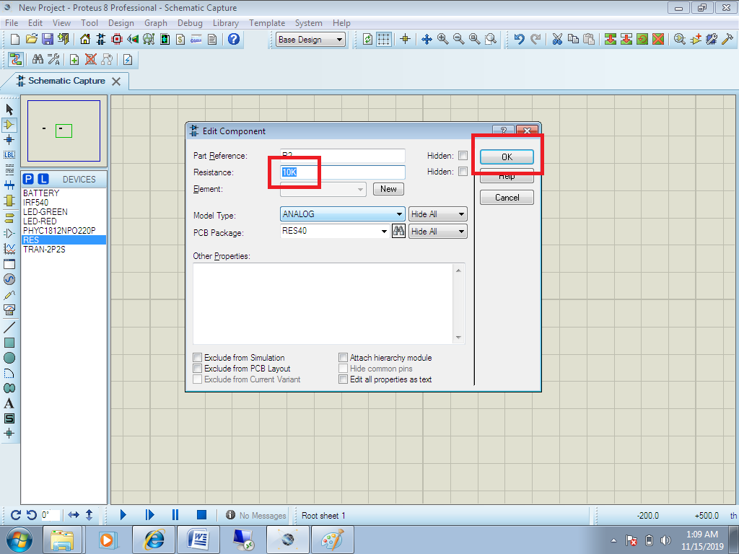

We can also rotate the component to make it appear as we shall require it.

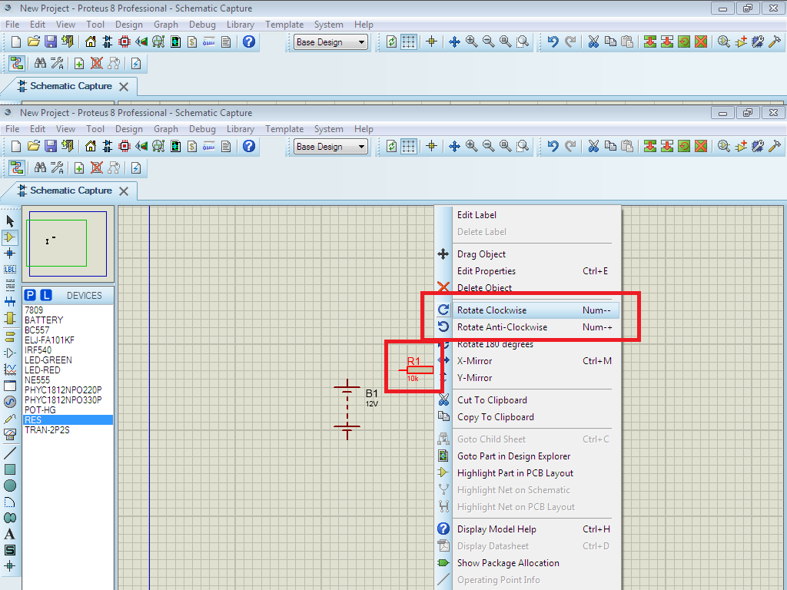

Place all the components in the space you will require them to appear and they will be displayed as shown below from the print screen.

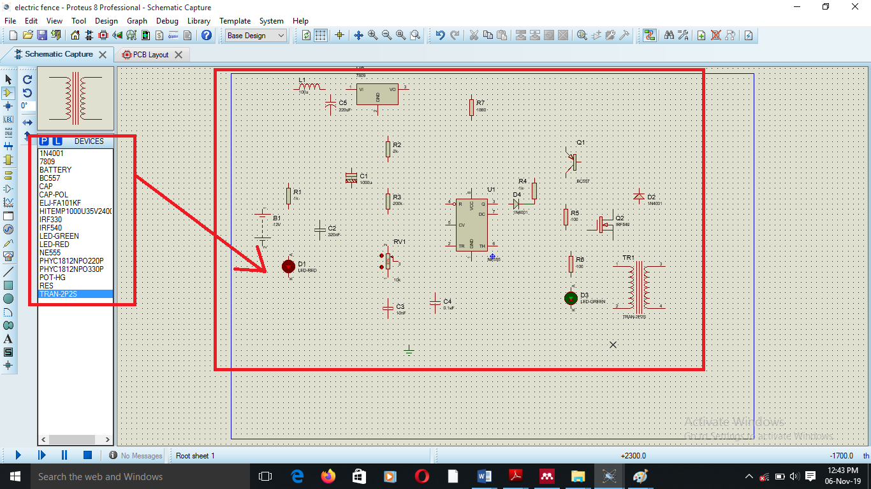

1. **Connecting the wires to the components**
2. Connecting the devices or components to each other as you require by wires.
3. Click on the icon shown in red and then move to the end of the components click and move the line or wire to the end of the next component you will need to connect to it.

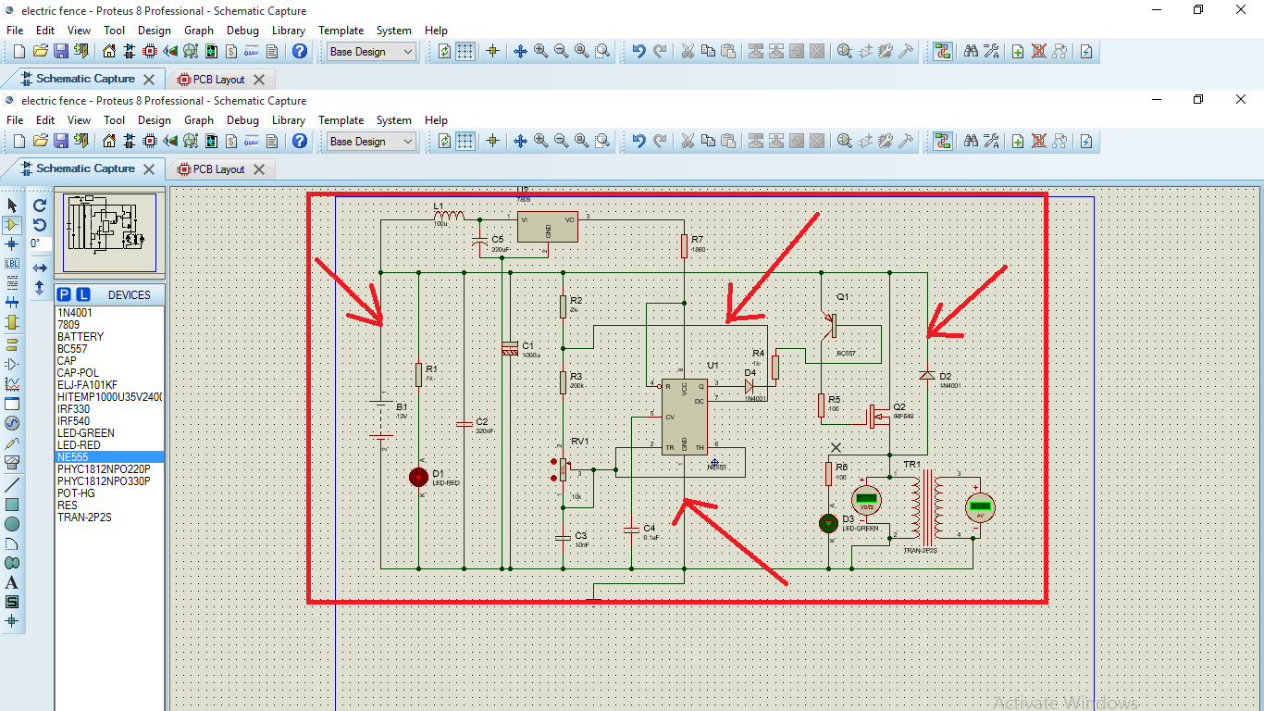

#### **Earthing**

PROSPICE will attempt to define a sensible earth point for any active circuit which does not specifically include a ground terminal in practice this is usually chosen as the mid-point of the battery or the Centre tap if the circuit has a split supply it follows that the positive terminal of the battery will sit above ground and the negative terminal below it, corresponding to red and green wire colors.

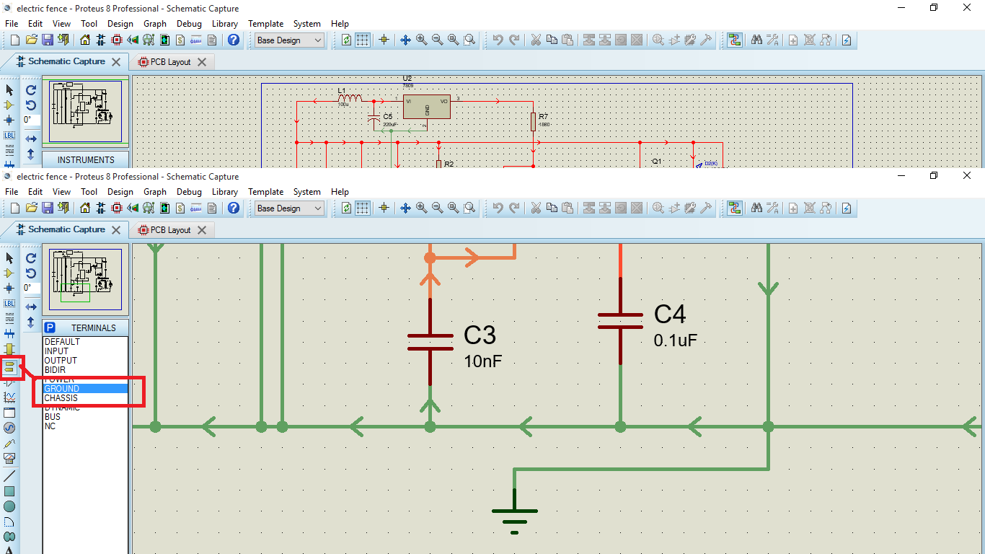

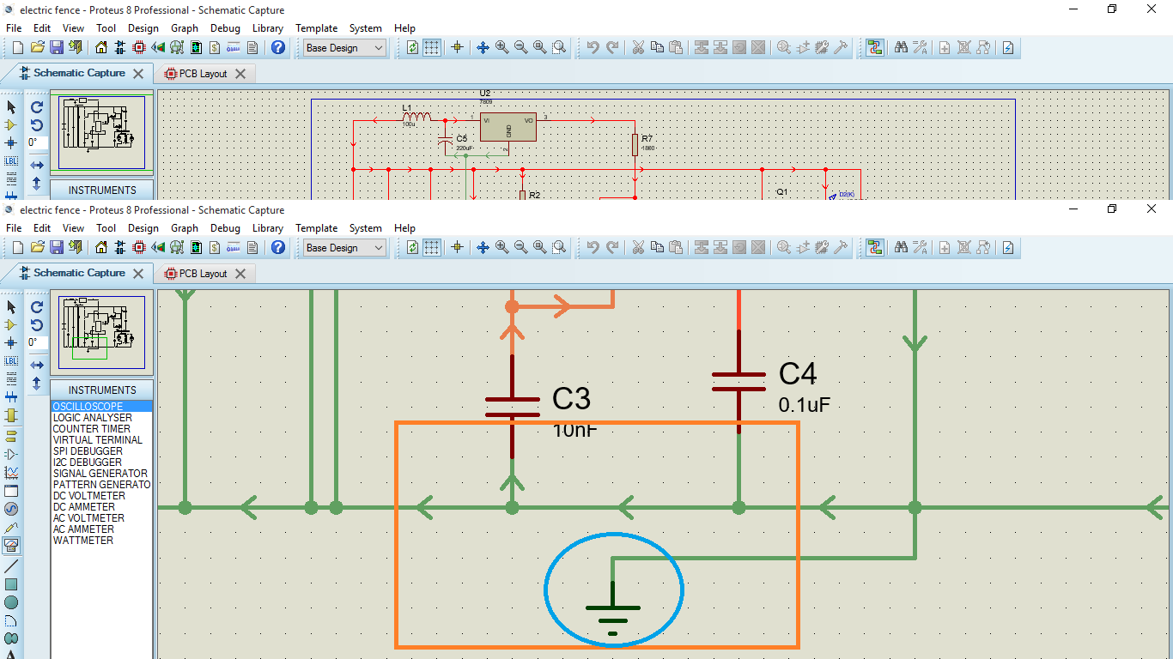

### **Wire labels**

Wire labels are used to assign particular net names to groups of wires and pins and also to assign net properties to specific nets. They are not in fact proper objects in the general scheme of the software.

#### **Placing and editing wire labels**

1. Select the wire label icon and mode selector toolbar.

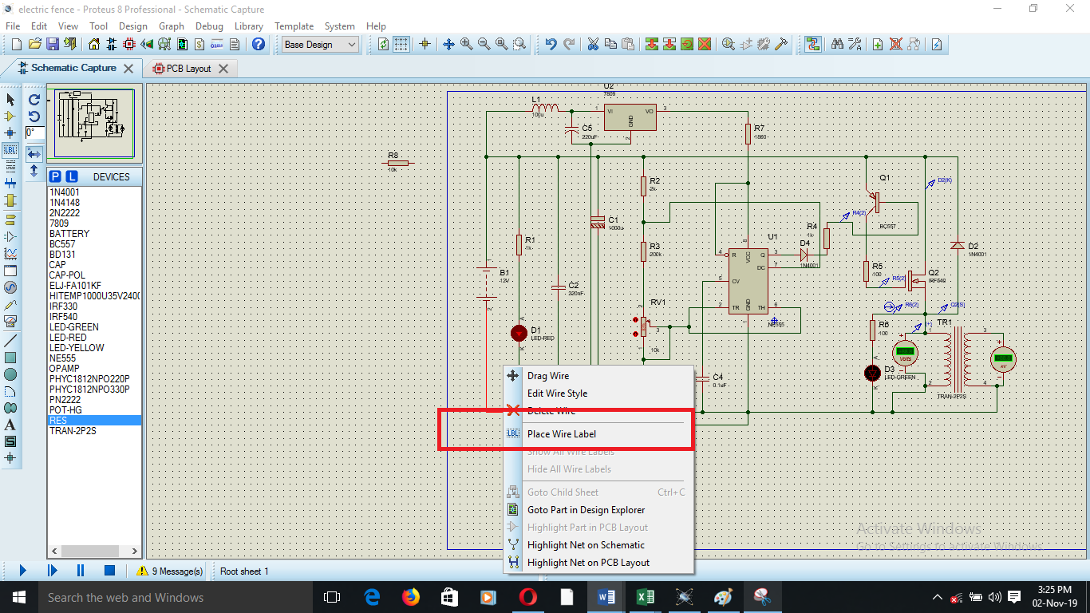

1. If placing a new label, point at the wire at the position where you want the label to be placed for an existing label, point anywhere along the wire or the label itself.
2. Left click to place the label. The create wire label or edit wire label dialogue form will be displayed.
3. Type in the required text for the wire label.

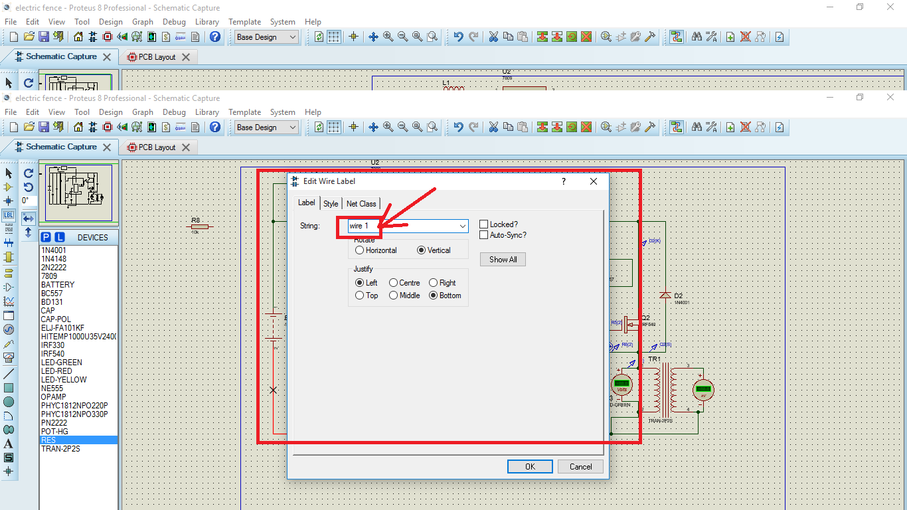

1. Click OK or press ENTER to close the dialogue form.

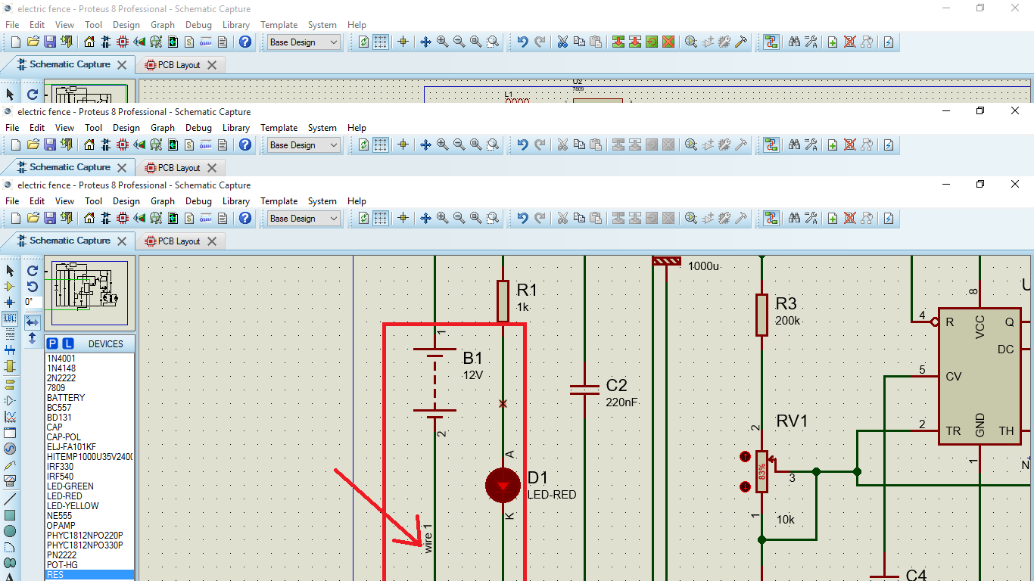

#### **To change the appearance of a wire**

1. Ensure the wire label icon is not selected
2. Tag the wire by pointing at it and right clicking
3. Left click on the tagged wire
4. Uncheck the follow global, check boxes of those style attributes of the graphics style you want to change.
5. Set the style attribute to the required setting.
6. Press ENTER or click OK button to close the dialogue form and keep the changes.

#### **Deleting wire labels**

1. Tag the wire label by pointing at either and clicking right.
2. Bring up the edit wire label dialogue form by clicking left on the label.
3. Ensure the label string text is fully selected and press DEL to delete it.
4. Click OK or press ENTER to close the dialogue form and save changes.

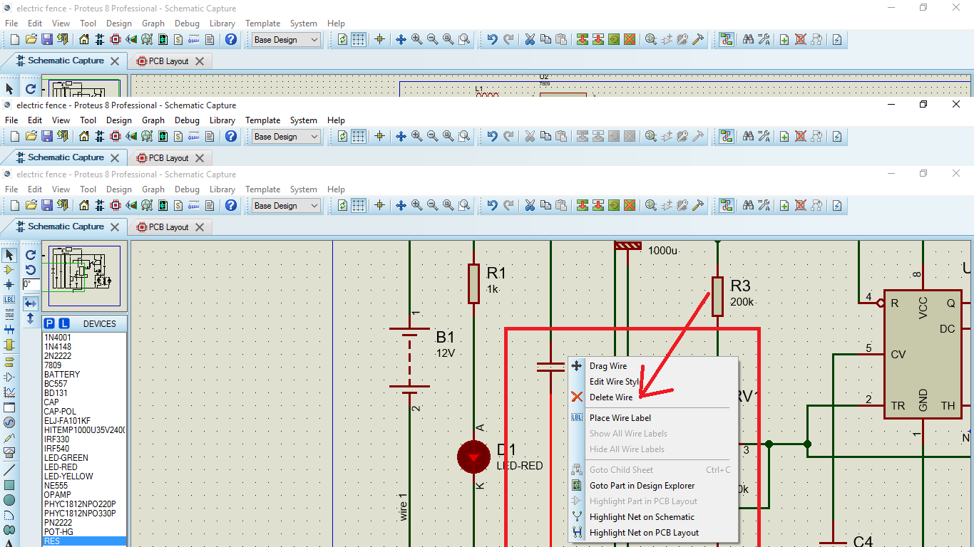

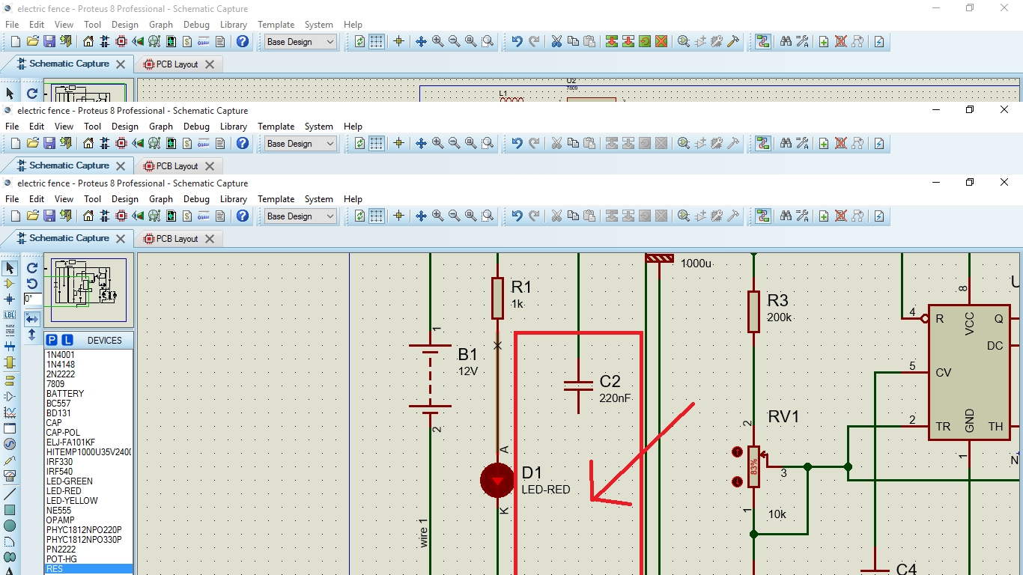

1. **Completed schematic circuit diagram**

Now we have the schematic as we shall require it before we can then run the simulations as shown below. Ensure all the components have been connected to each other as required and there are no disconnection errors.

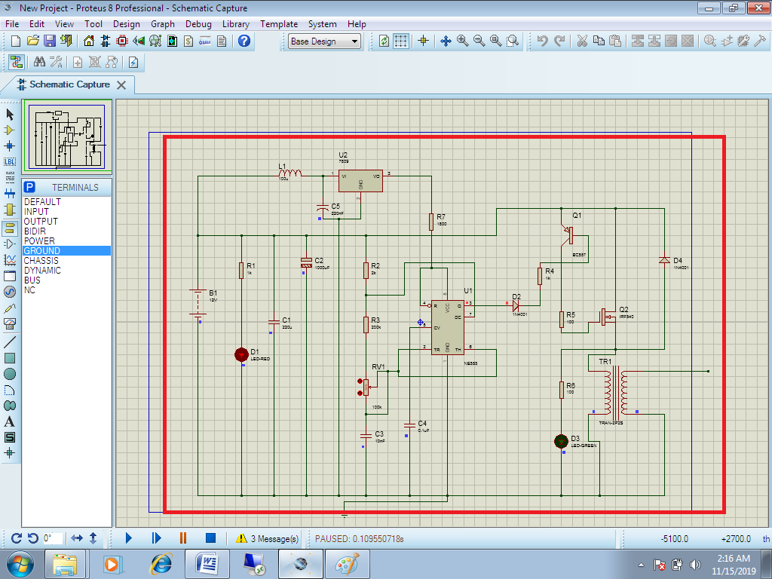

1. **Complete circuit system simulating.**

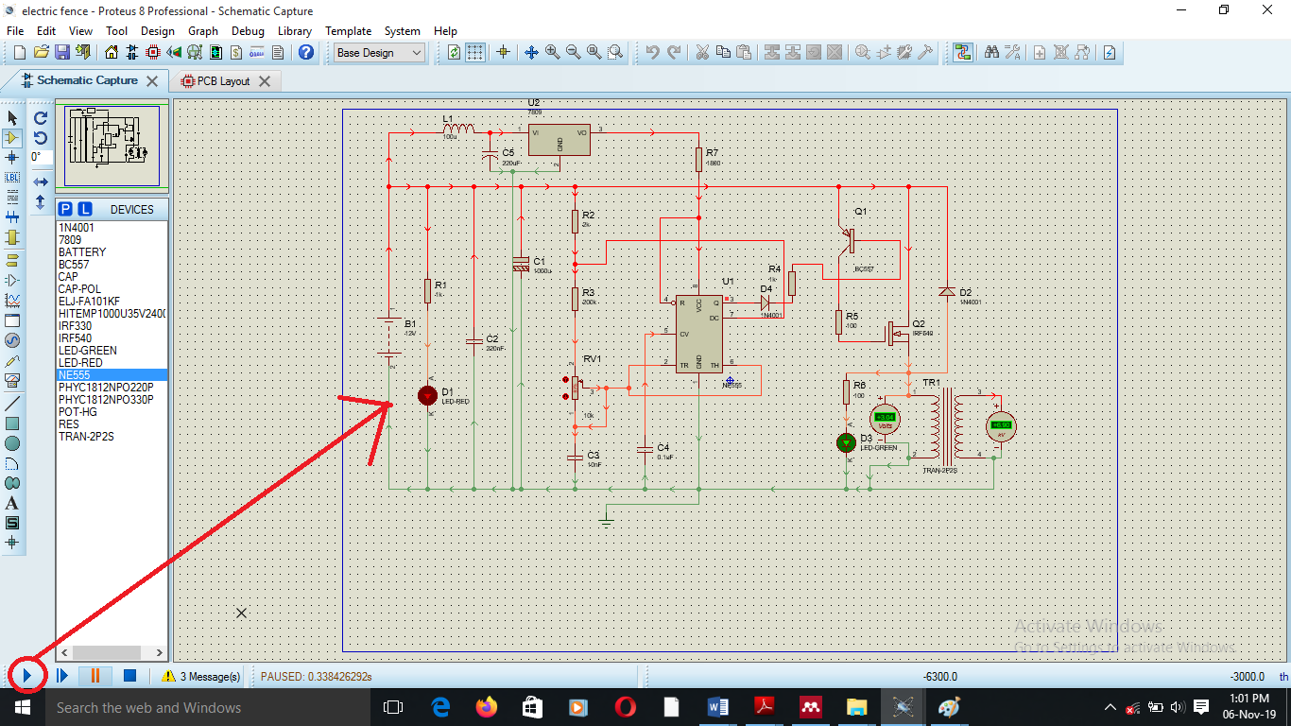

#### **Oscilloscope**

**Using the oscilloscope**

**To display 20% duty cycle waveforms**

1. Pick the oscilloscope object from active component library, place one on the schematic and wire its input to the signals you want to record.
2. Start an interactive simulation by pressing the play button on the animation control panel. The oscilloscope window should appear.

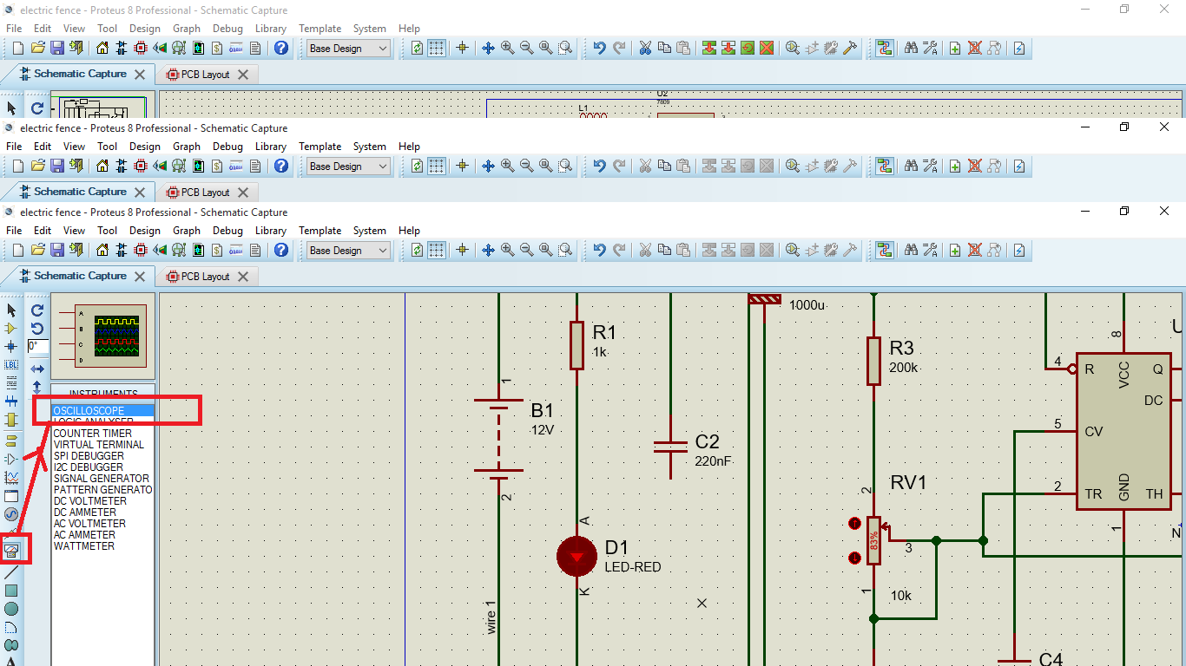

1. If displaying two signals, select dual mode.
2. Set the time base dial to a suitable value for the circuit. You will need to think about waveform frequencies present in your circuit.
3. If displaying signals with DC offset, select AC mode on either or both input channels as appropriate.
4. Adjust the Y-gain and Y-pos dials so that the waveforms are of a suitable size and position.
5. Decide which channel you want to trigger off, and ensure that the ch1 or ch2 led is lit, as appropriate.
6. Rotate the trigger dial until the display locks to the required part of the input waveform.

Generated pulses from the oscilloscope .The pulses generated are for the 20% duty cycle as expected for an electric shock that can give the animal a chance to draw back.

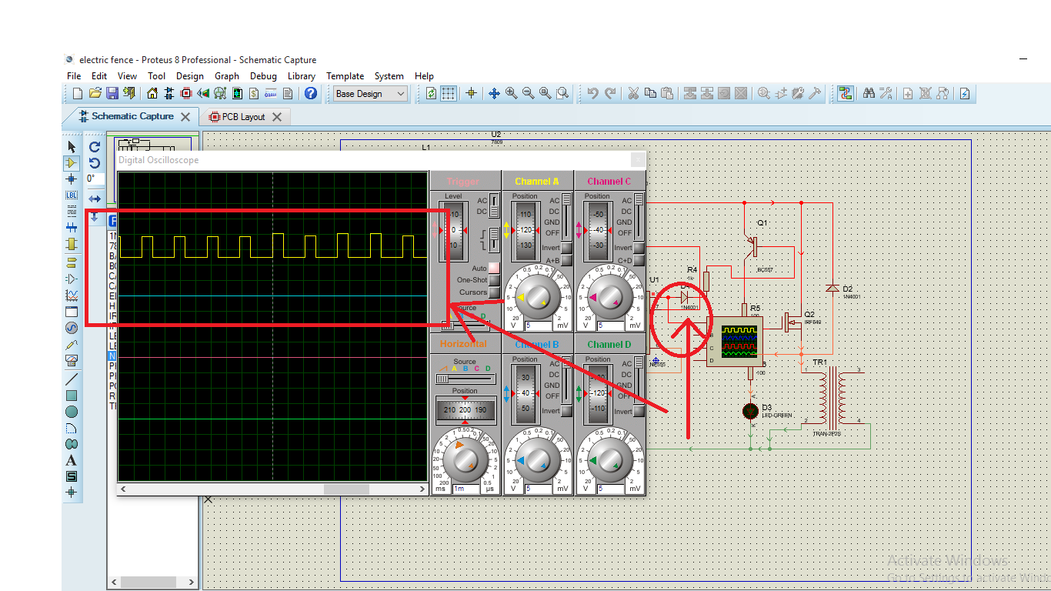

1. **Changing properties and parameters**

Since some components like the transformer will require particular parameters for the secondary and primary sides for us to be able to achieve the required voltage. Certain parameters had to be edited by righting on the component for example the transformer from which we were able to edit properties of secondary and primary as we calculated them on paper.

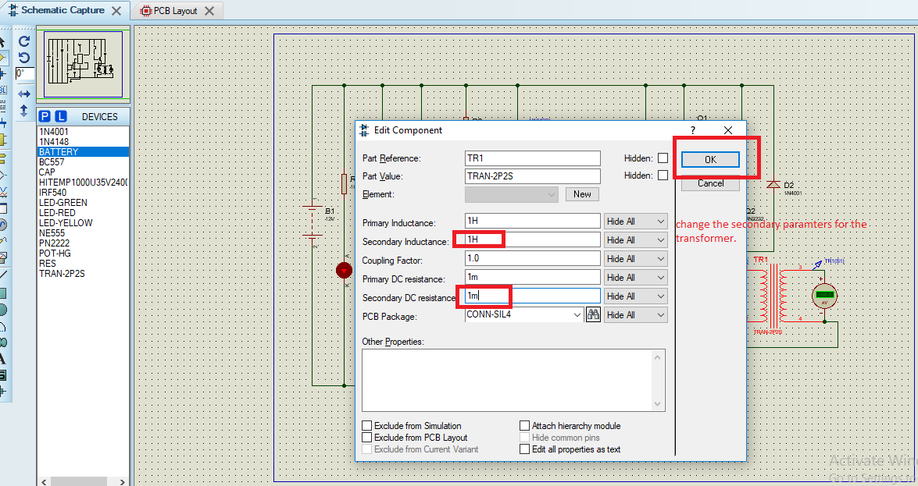

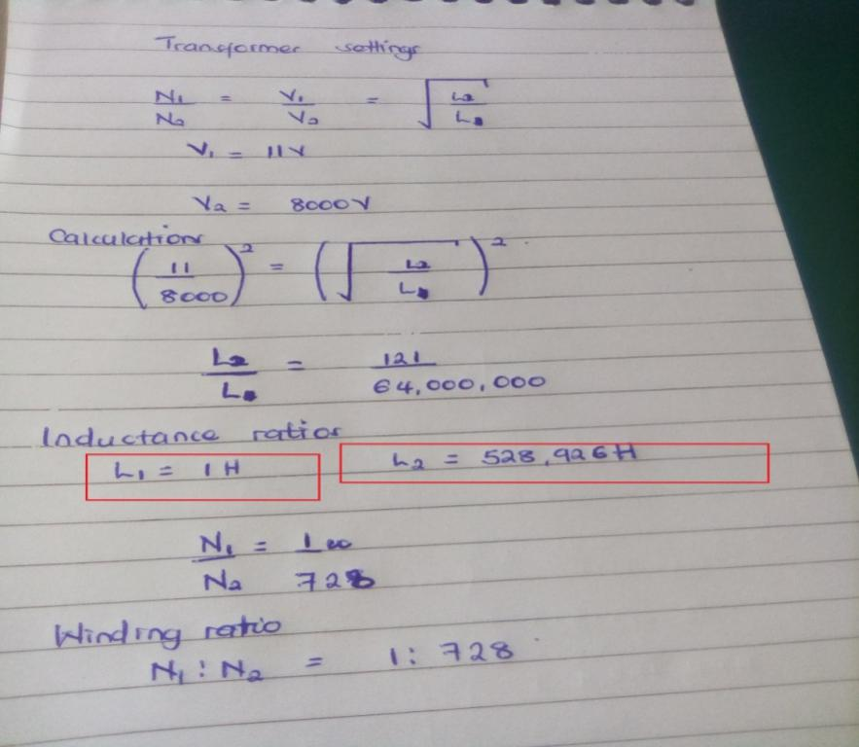

We can then what is highlighted in the red boxes above to what is required as shown and later click okay in the box highlighted to have it in place.

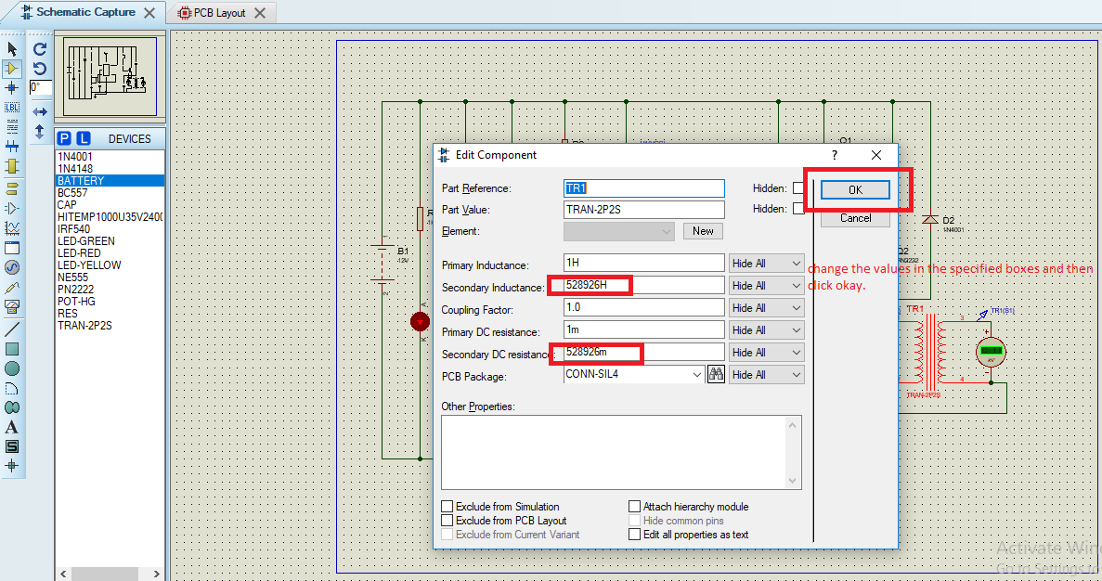

This can be done for any component as you will want to edit its properties. After all the editing is done, you can then run the simulations and ensure no errors are displayed.

### **Voltmeter and Ammeters**

A number of interactive voltmeter and ammeter models are provided in the ACTIVE device library. These operate in real time and can be wired into the circuit just like any other component. Once the simulation is started they display the voltages across their terminals or the current flowing through them in an easy to read digital format.

The voltmeter object can display values from 0.01Vup to 99.9V while the ammeter can display from 0.01mA to 100mA and so on.

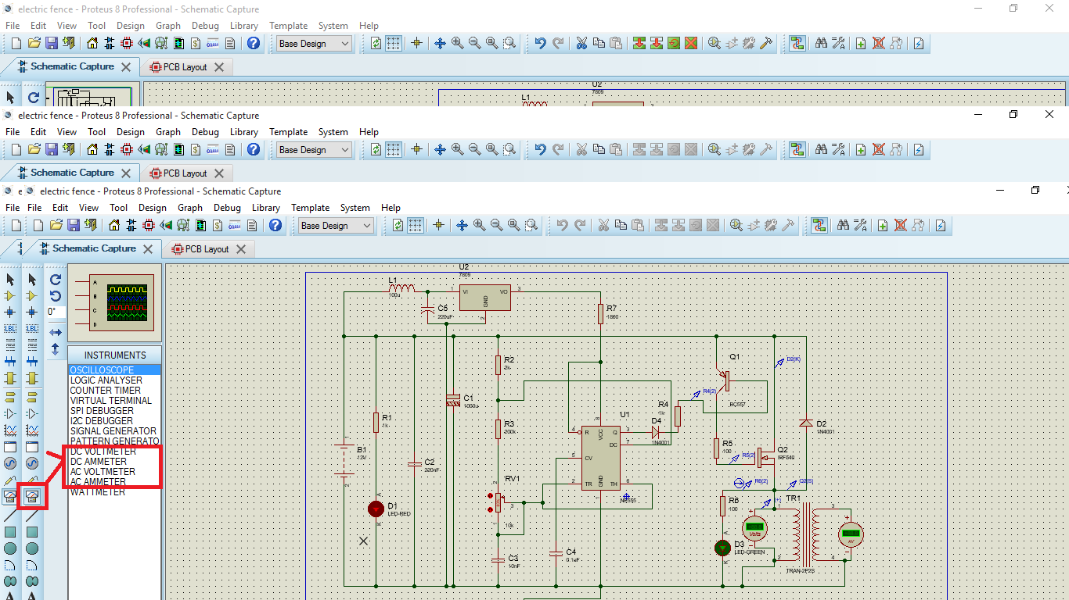

#### **Measurement of voltage and current**

After running the simulation as it runs as required, we shall need to know the voltage at the transformer input and at the secondary output.

So we use a DC voltmeter to the primary and secondary as shown below and can have the values read as we require them. And since we are supplying DC voltage we expect the output to be DC so we use a DC voltmeter.

.

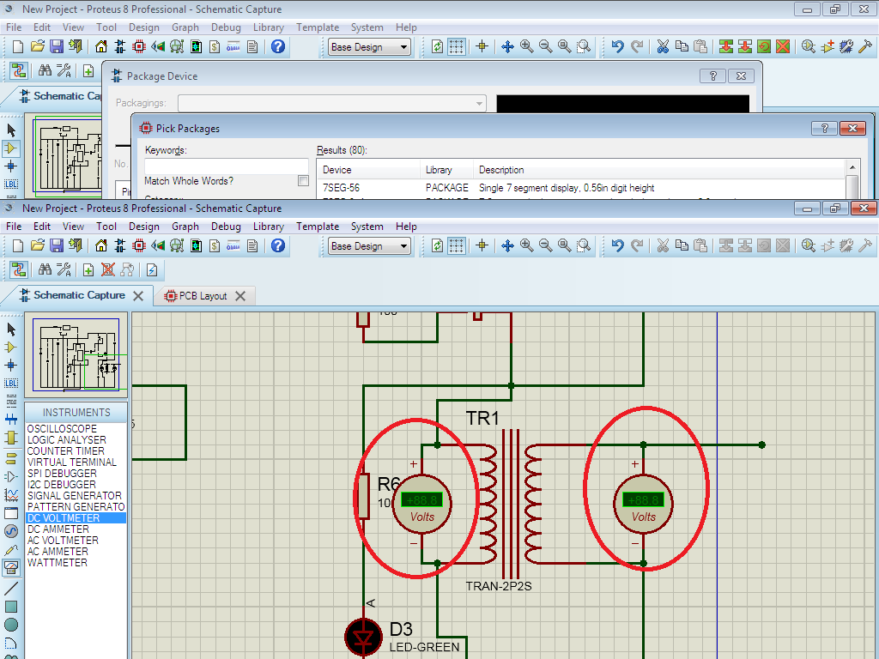

#### **Using voltage probes**

Having defined the input to our circuit using a generator, we must now place probes at the points we wish to monitor. We obviously interested in the output and the input after it has been biased is also useful point to probe. If need be, more probes can always be added at key points and the simulation repeated.

To place a probe, first click left on the voltage probe icon (ensure you have not selected a current probe by accident).probes can be placed onto wires, or placed and then wired, in the same manner as generators.

We can also be in position to measure voltage and current at particular points in the circuit as shown in the print screens below.

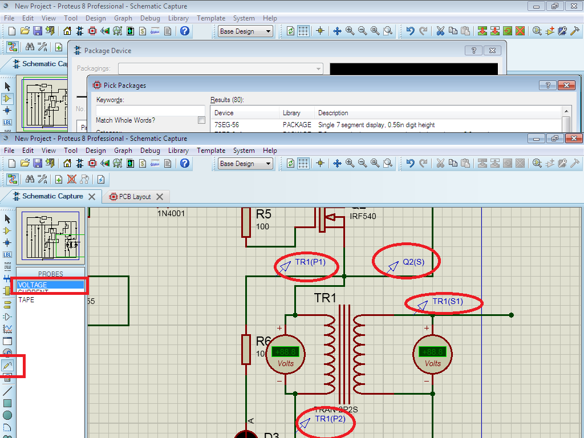

#### **Using current probes**

Current probes are used in the same manner as voltage probes but with one important difference. A current probe needs to have a direction associated with it. Current probes work by effectively breaking a wire and inserting themselves in the gap, so they need to know which way round to go. This is done simply by the way they are placed in a default orientation a current probe measures current flow in a horizontal wire from left to right.

Select a current probe by clicking on the current probe icon. Click left on the clockwise rotation icon such that the arrow points downwards.

We can also be in position to measure current at particular points in the circuit as shown in the print screens below.

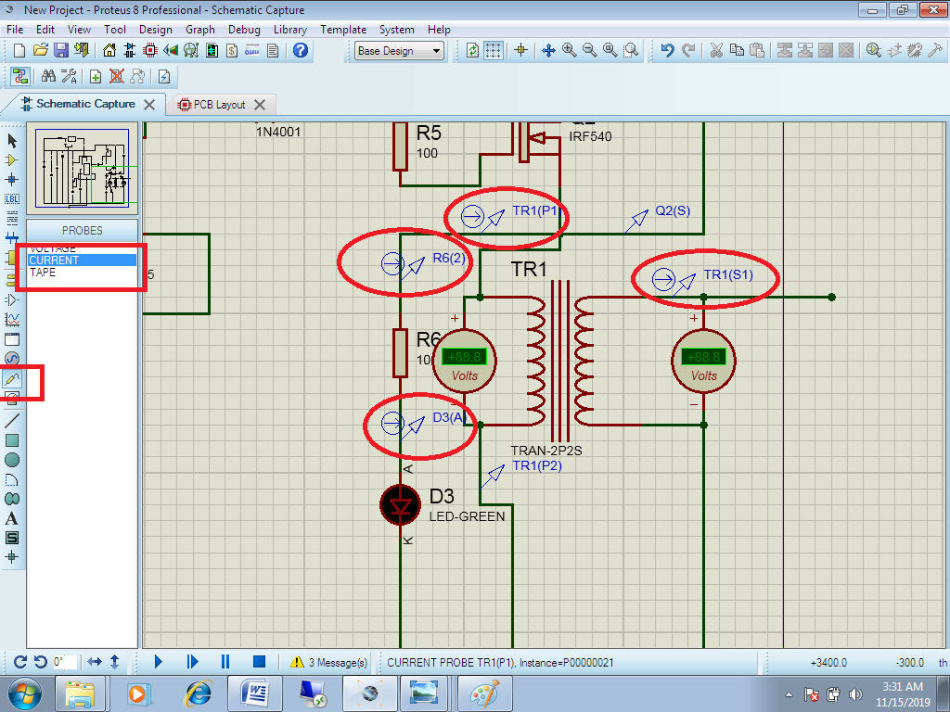

1. **Running the simulation.**

Click on the play button on your screen and have the simulations running.

And since we shall want to watch how our voltage and current will flow we make some changes from the systems dialog, from which we shall find set system animations and then tick on the voltage and current dialogs as shown below. We shall later have our print screen showing how current and voltage will flow to our output.

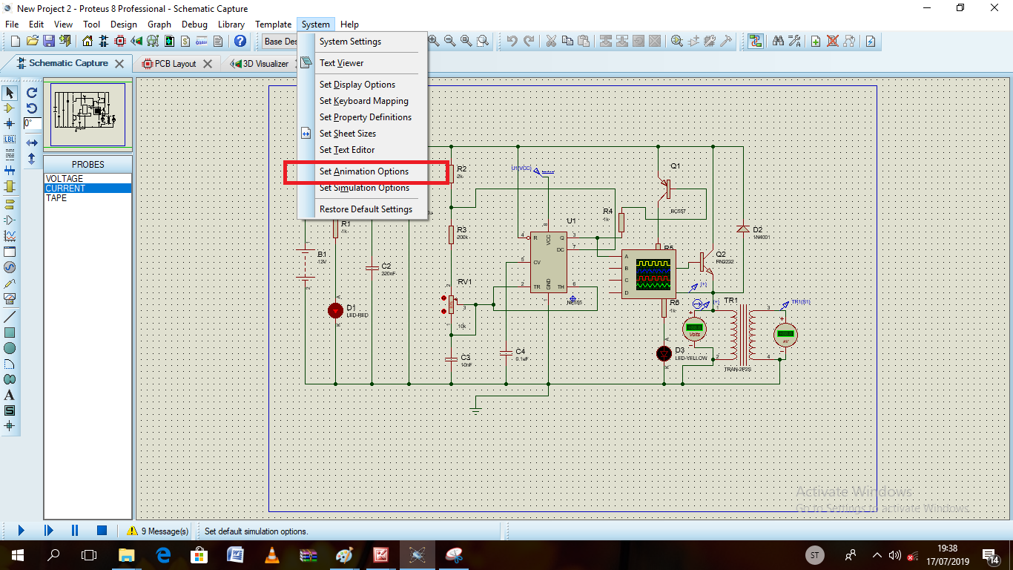

#### **Show wire voltage as color**

This option causes any wire that is part of an analogue or mixed net to be displayed in a color that represents its voltage.

The voltages may be changed on the set animation options dialogue and the colors set via the set design defaults command on the template menu.

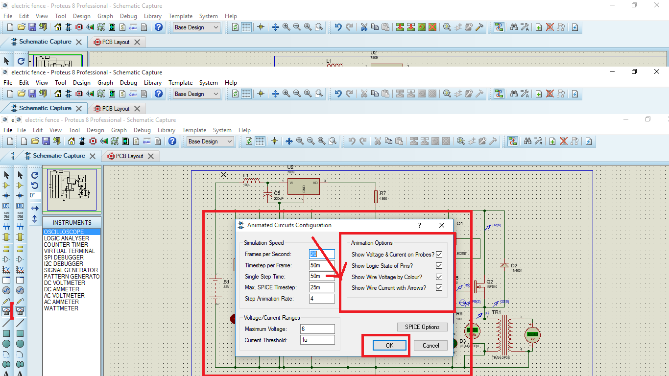

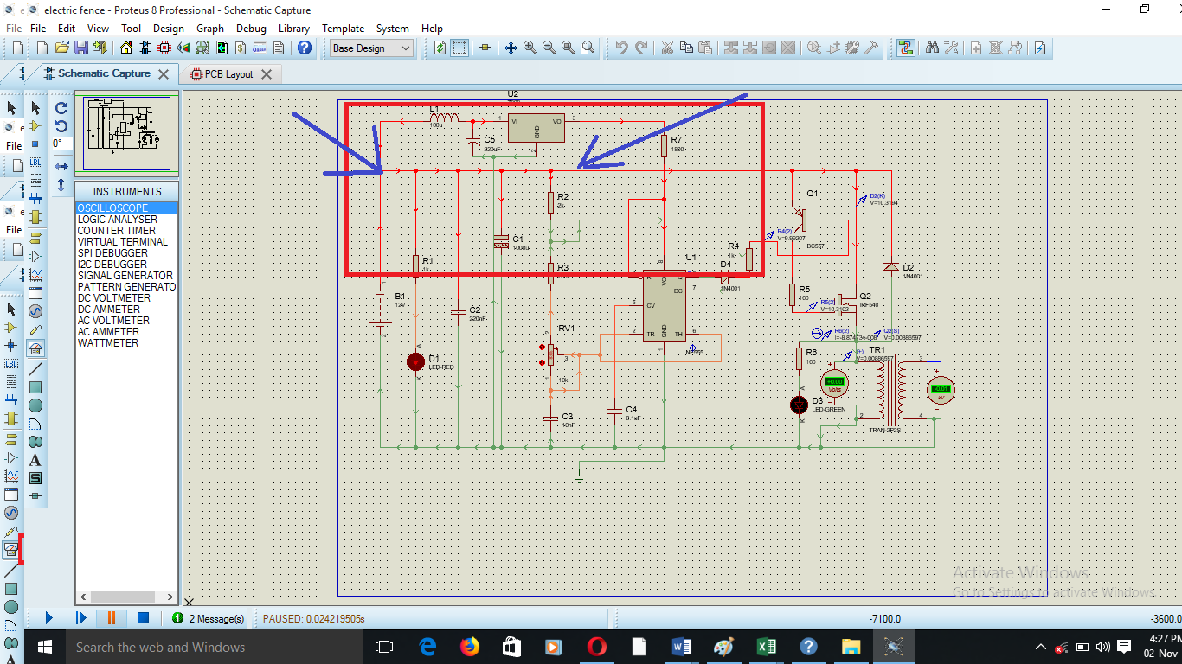

#### **Show the wire current as arrows**

This option causes an arrow to be drawn on any wire that carrying current. The direction of the arrow reflects conventional current flow and it is displayed if the magnitude of the current exceeds a threshold.

And since we shall want to watch how our voltage and current will flow we make some changes from the systems dialog, from which we shall find set system animations and then tick on the voltage and current dialogs as shown below. We shall later have our print screen showing how current and voltage will flow to our output.

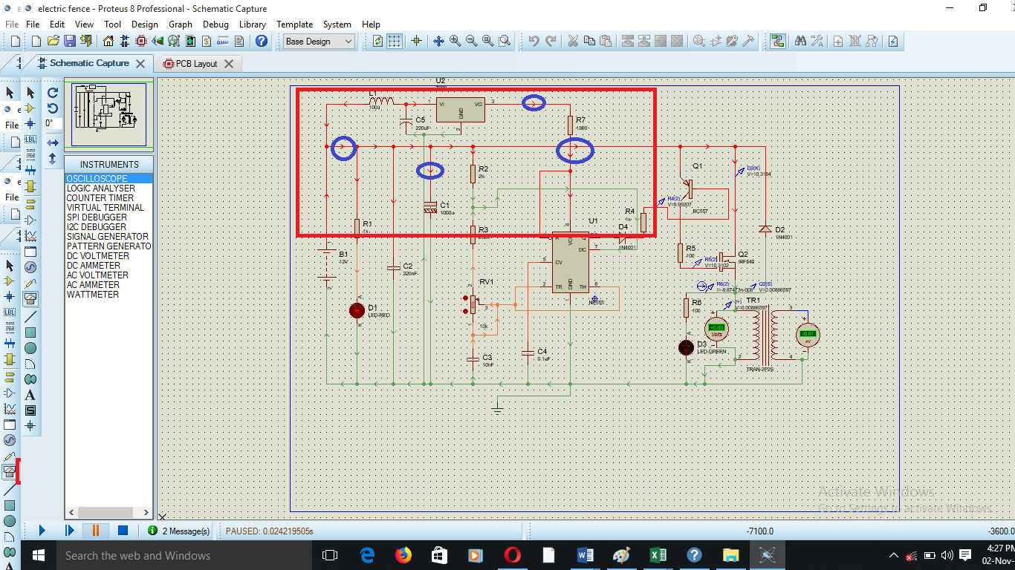

#### **Animation control panel**

Interactive simulations are controlled from simple VCR like panel that behaves just like a normal remote control. This is situated on the bottom left of the screen.

There are four buttons that you use to control the flow of the circuits.

* The PLAY button is used to start the simulator.
* The STEP button allows you to step through the animation at a defined rate.
* The PAUSE button suspends the animation which can then be resumed either by clicking the PAUSE button again.

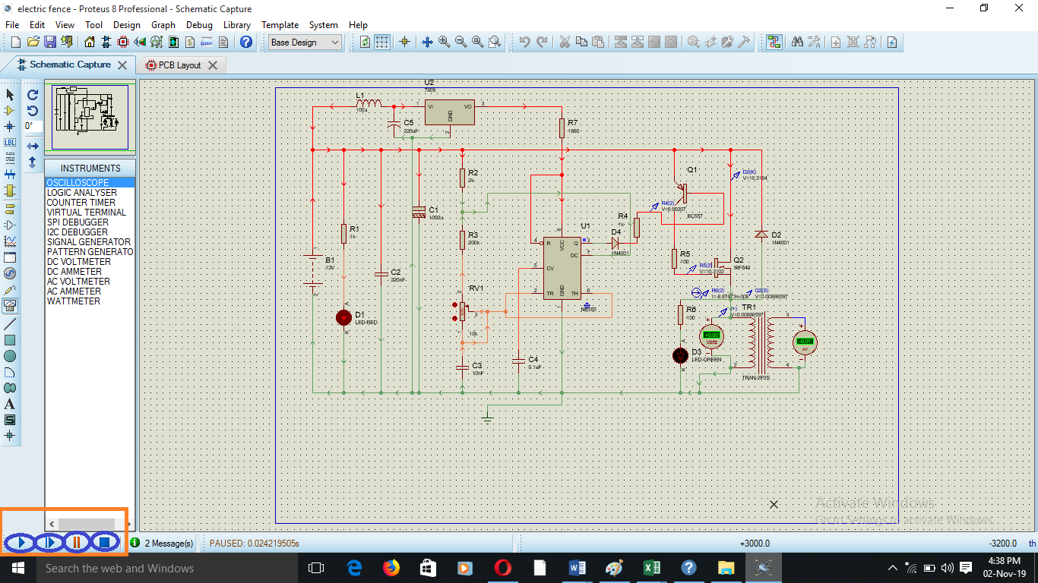

The STOP button tells PROSPICE to stop doing a real time simulation. All animation is stopped and the simulator is unloaded from memory. All indicators are reset to their inactive states but switches retain their existing settings.

**Trouble shooting errors in case of a problem**

##### **Simulation log**

Whenever the simulation is performed a simulation log file is created. The simulation log file contains all information, warning and error messages from both the simulator itself and from individual models.

In case the simulation fails completely, the log file will be displayed automatically in order than you can see the cause of the problem immediately.

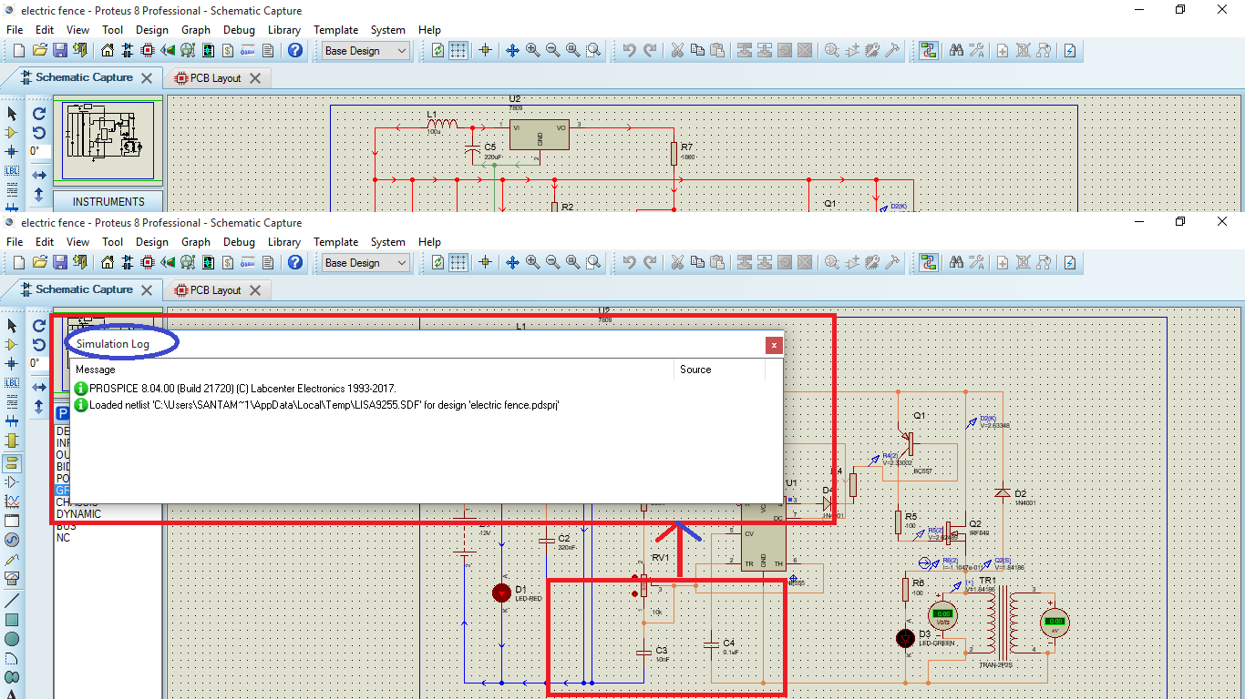

##### **Netlisting errors**

Netlisting errors occur as a result of a problem when ISIS tries to create a netlist from the schematic, you will also encounter these if you try to export the schematic for PCB layout. Common ones are;

* Having two components with the same name, or unnamed components for example two resistors labelled R.
* Badly mapped scripts.

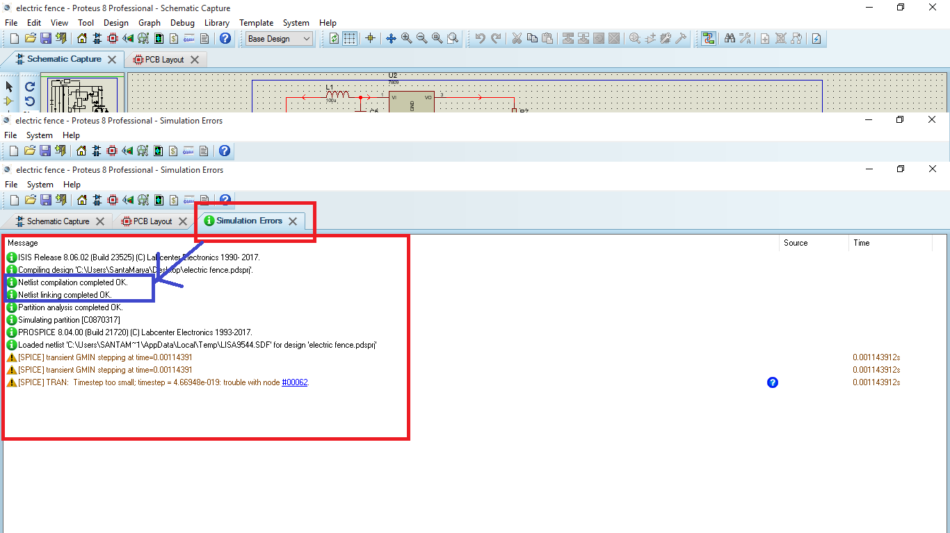

##### **Partitioning errors**

Partitioning is a mechanism by which ISIS decides which parts of the circuit need to be simulated. Problems that can occur here are;

* Cyclic dependencies detected. This means that an arrangement of tapes is such that the partitions behind and in front of a tape are mutually dependent.
* No model specified, this means that the component indicated does not have a primitive property and has appeared in that part of the circuit which needs to be simulated.

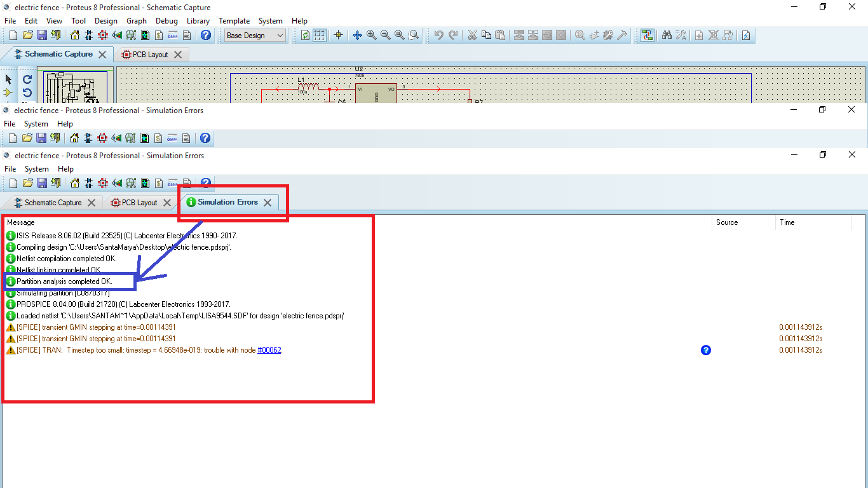

##### **Simulation errors**

Simulation errors are generated by PROSPICE rather than ISIS and therefore occur after a netlist has been successfully generated. Common problems that get detected include;

* Device type not recognized. This means you have specified a primitive type that is not supported.
* No DC path to ground.
* Could not find probe, you have tried to reference a probe or voltage generator that does not exist.
* Cannot open SPICE source file. The source file specified in the spice model property cannot be located.
* Cannot find library model.

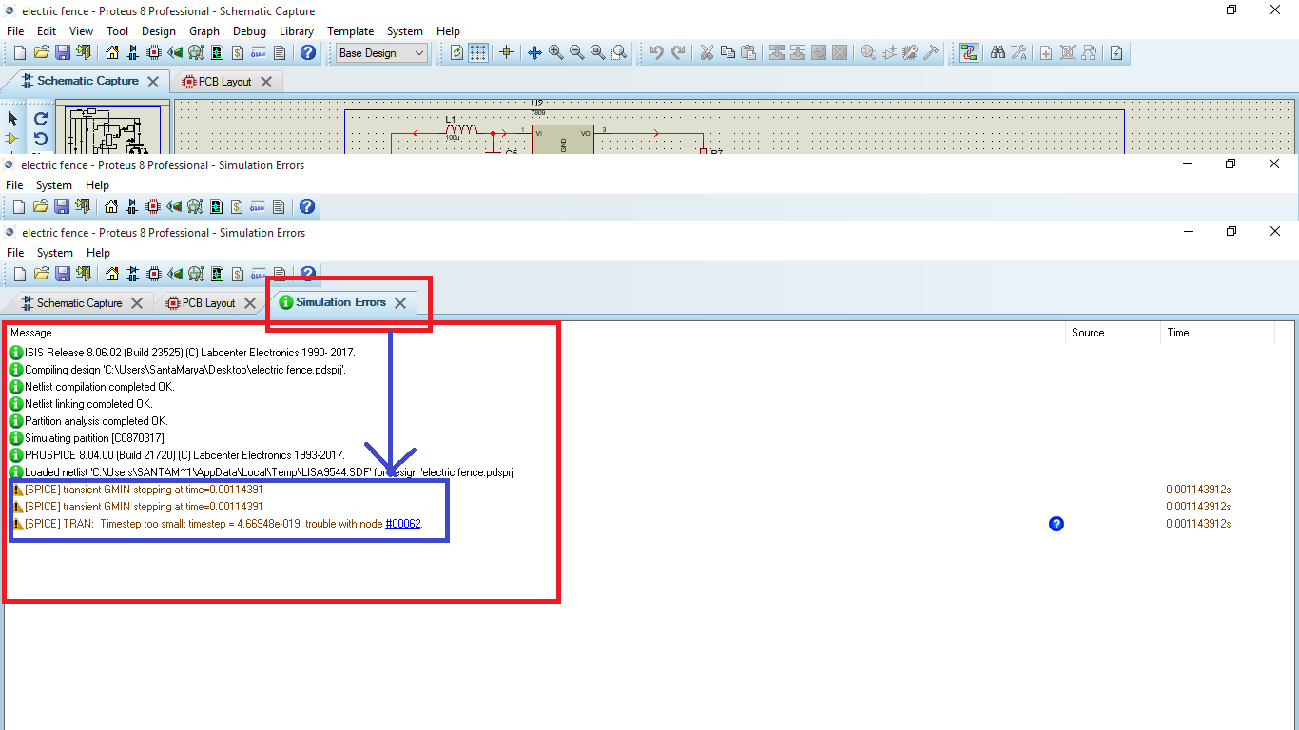

##### **Convergence problems**

These errors relate to what happens if SPICE itself fails to simulate the circuit. There are basically three error messages that indicate this;

* Singular matrix. This usually relates to circuits which are mis-drawn or in which some initial conditions need to be given in order to define the starting state.
* Too many iterations without convergence. This means that circuit solution is unstable.
* Time step too small. This means that the circuit has switched in such a way that advancing the time even by very small amounts still does not produce an acceptably small change in circuit voltages.

**Printed circuit board**

Select the icon highlighted in the red box to have a PCB Layout of the schematic diagram as shown in the proceeding print screens.

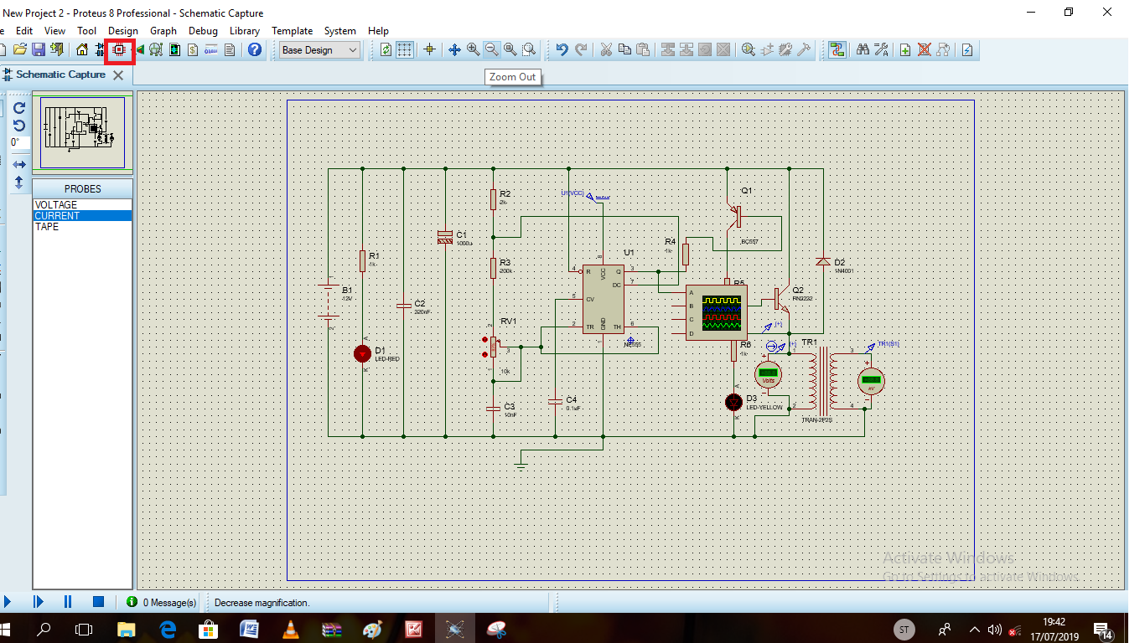

## **Printed circuit board**

Select the icon highlighted in the red box to have a PCB Layout of the schematic diagram as shown in the proceeding print screens.

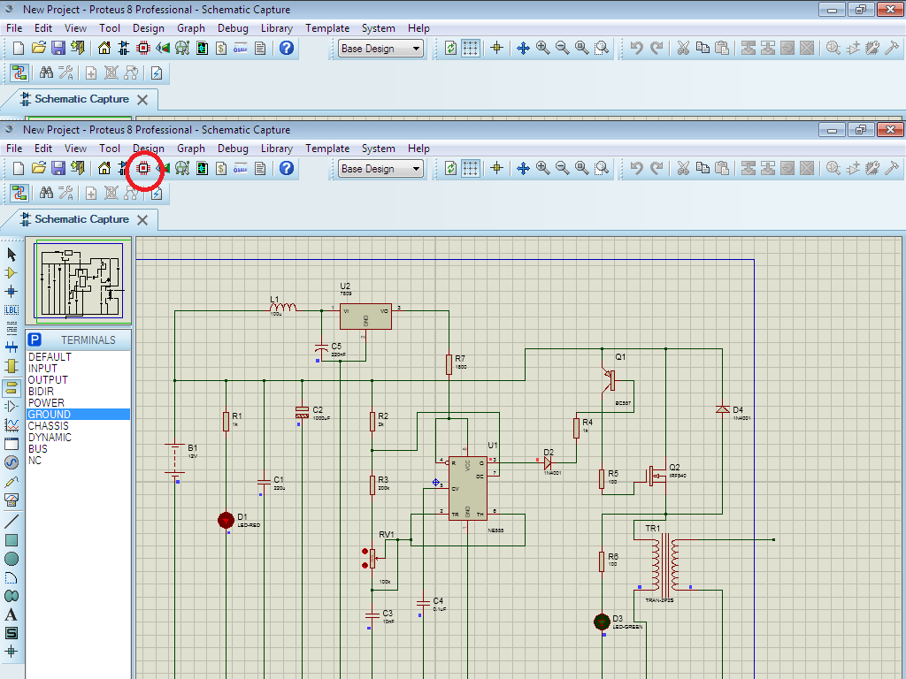

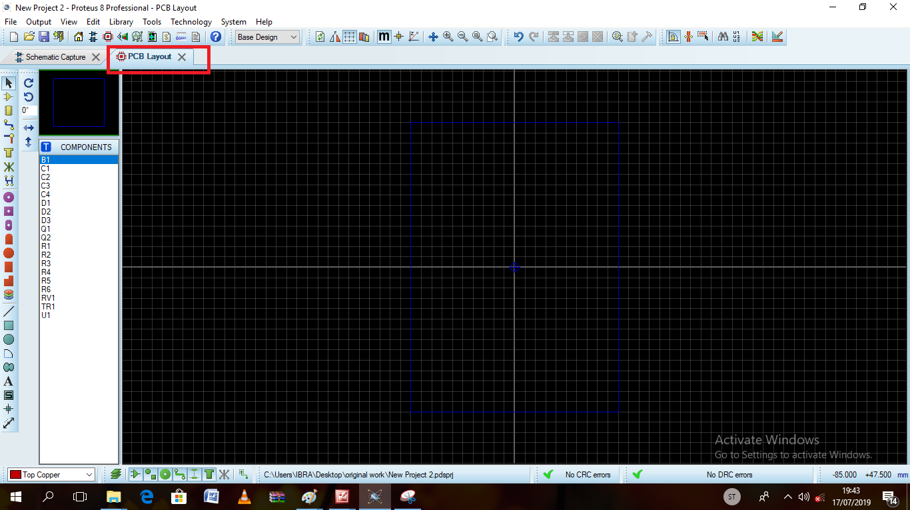

### **Board outline**

Proteus has a special layer, edge layer which is intended for holding 2D graphics which represent the board outline. Objects placed on the edge layer on artwork generated for any of the other layers.

In case, the board outline is just a box.

1. To place a rectangular board edge
2. Select the box icon
3. Select edge layer from the layer selector
4. Point at where you want the top left corner of the box, press the left mouse button and drag out the box to enclose the layout.
5. If you need to resize the box, tag it by pointing at it and right clicking and then drag the sizing handles using the left mouse button.

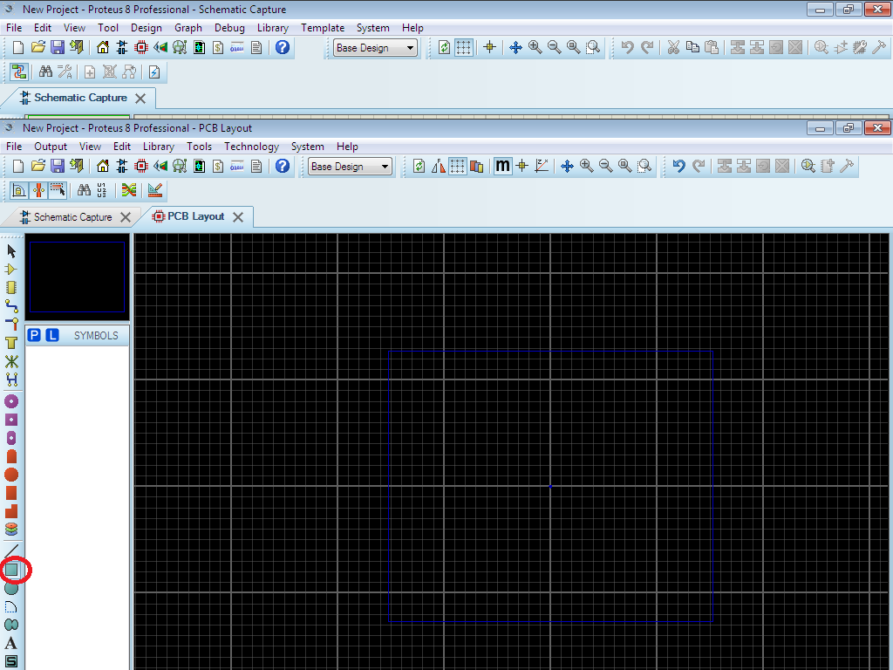

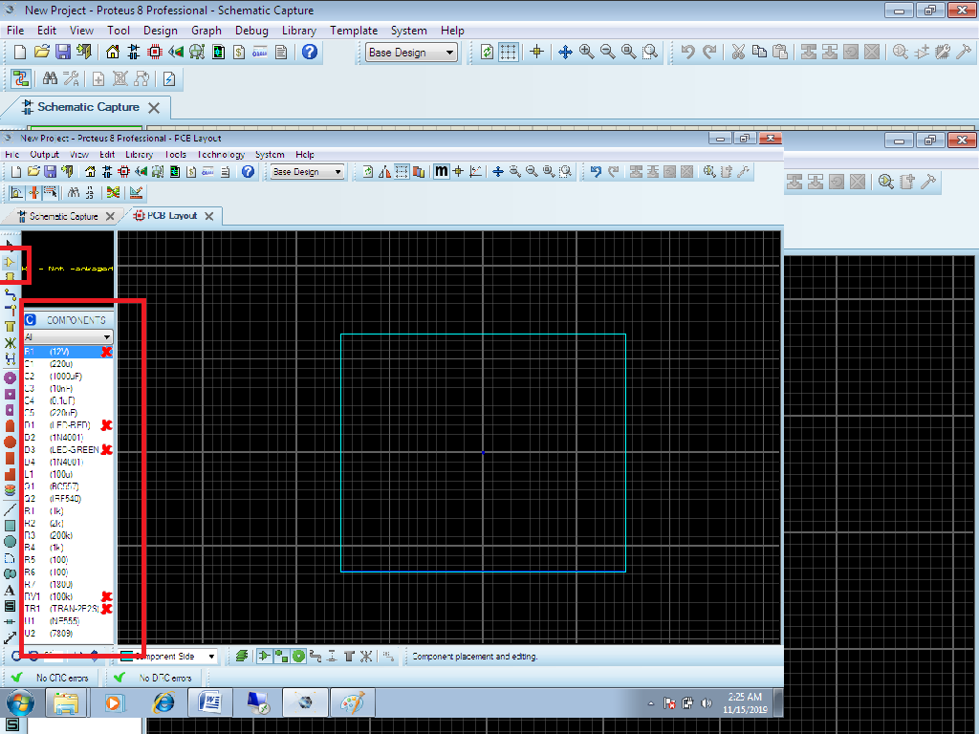

1. Placing missing PCB packages highlighted in the red crosses

We go back to our schematic diagram and right click on all components that don’t have a PCB package doing each at a time as shown for the case of the battery

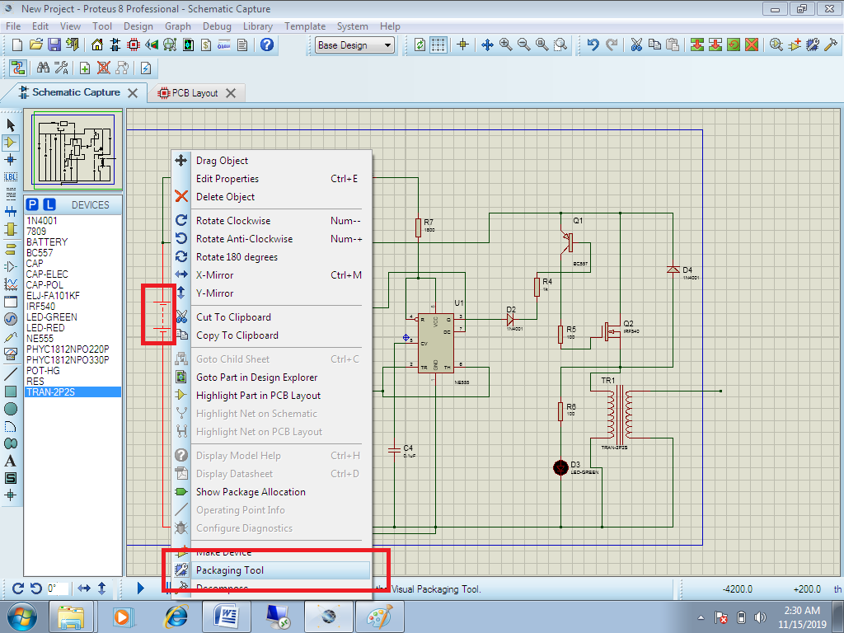

Then move to add highlighted in the red box

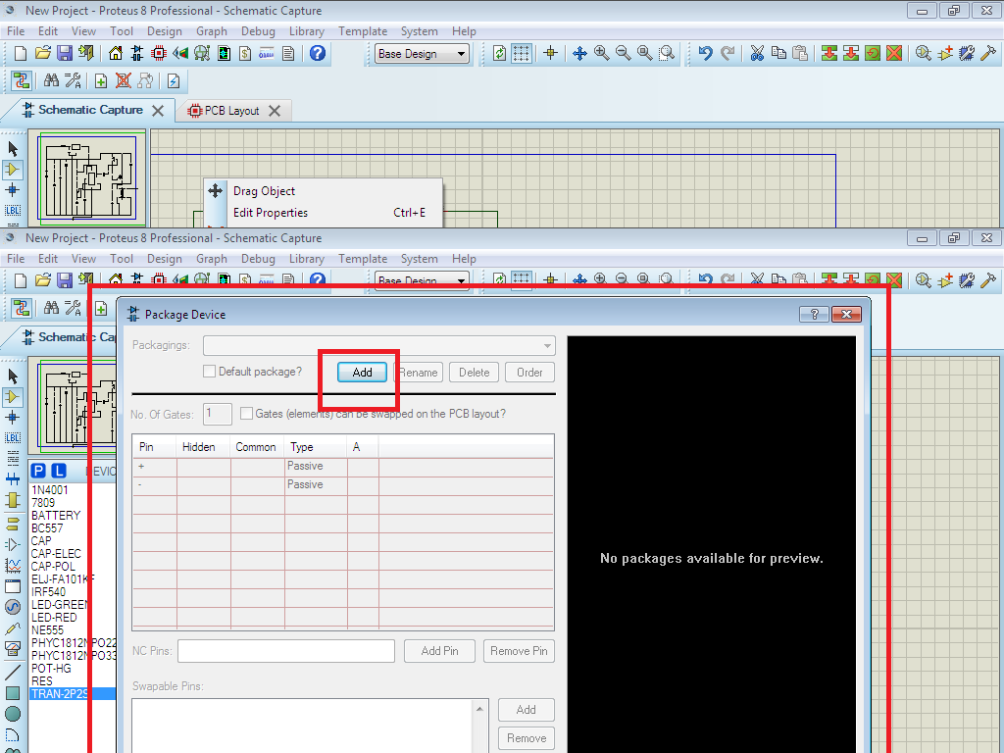

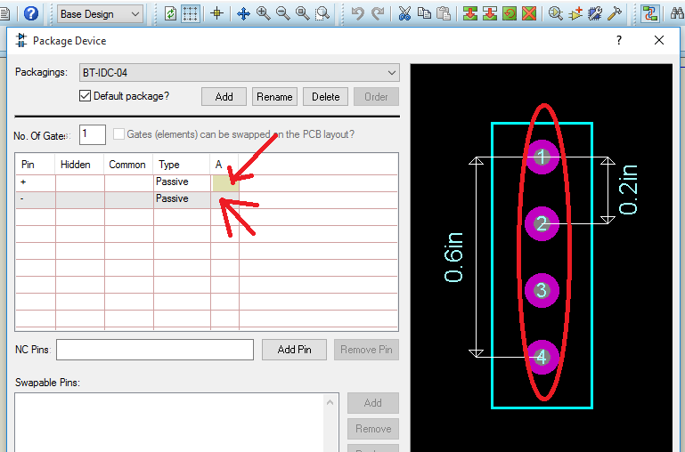

The terminals selected to be assigned are as shown

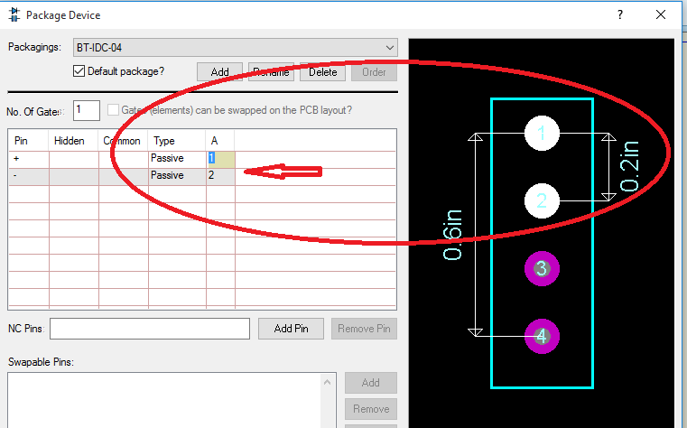

Click assign package followed by save packages

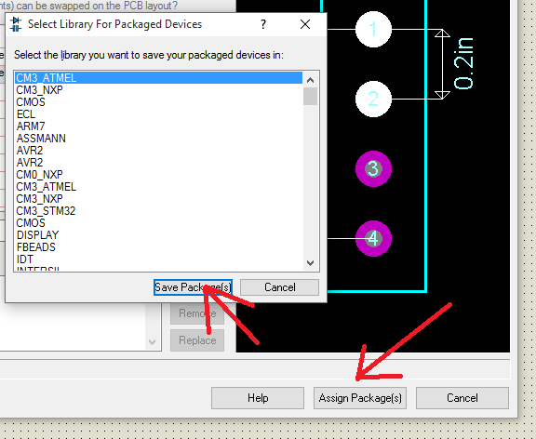

Accept by clicking yes

Do the same for the rest of the component that had a red cross on them and after all is done the components should appear as below with no red cross

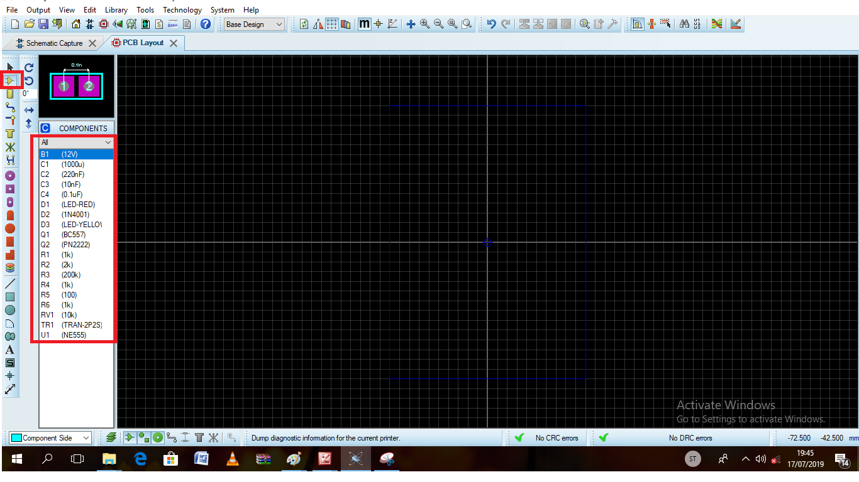

1. **Package placement**

You can pick a component package from the library and place them onto the work area.in our project,

the components used for example,

BV1

RVI

TRANS

And you can start by picking them from the package library to do this,

1. First click left on the package icon.
2. Click left on the P at the top left of the object selector which is now displaying the word PACKAGES.
3. The lick pick will appear and you pick the required packages from it.
4. When you have done this close down the form by clicking the close button.
5. The three package names should now have appeared in the objector selector.
6. Ensure that B1 is selected by left clicking on.
7. Point somewhere in the middle of the editing window and hold down the left mouse button.
8. A green outline of a 2 pin battery will appear which can move about with the mouse.
9. Position it roughly central and release the mouse button.

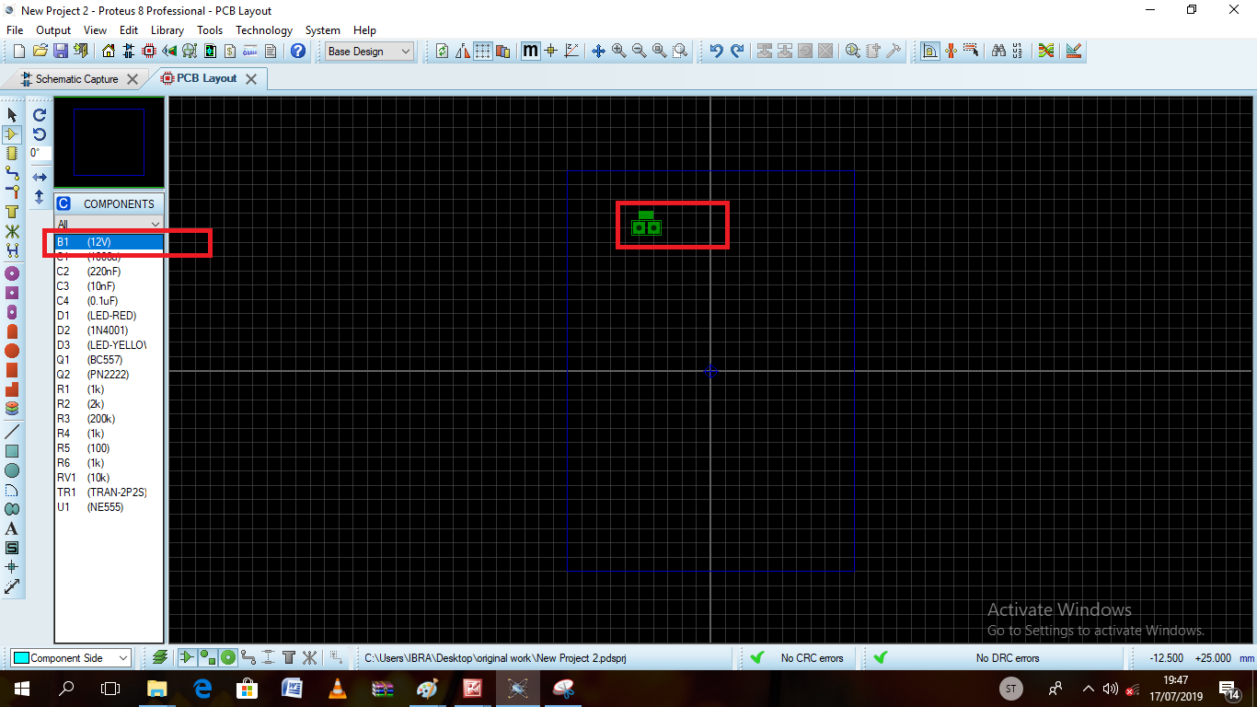

1. Now do the same and select all components and similarly place them on the layout.
2. Unless you are quite adept, you may have the components positioned quite correctly.
3. Point at a component outline and click right.

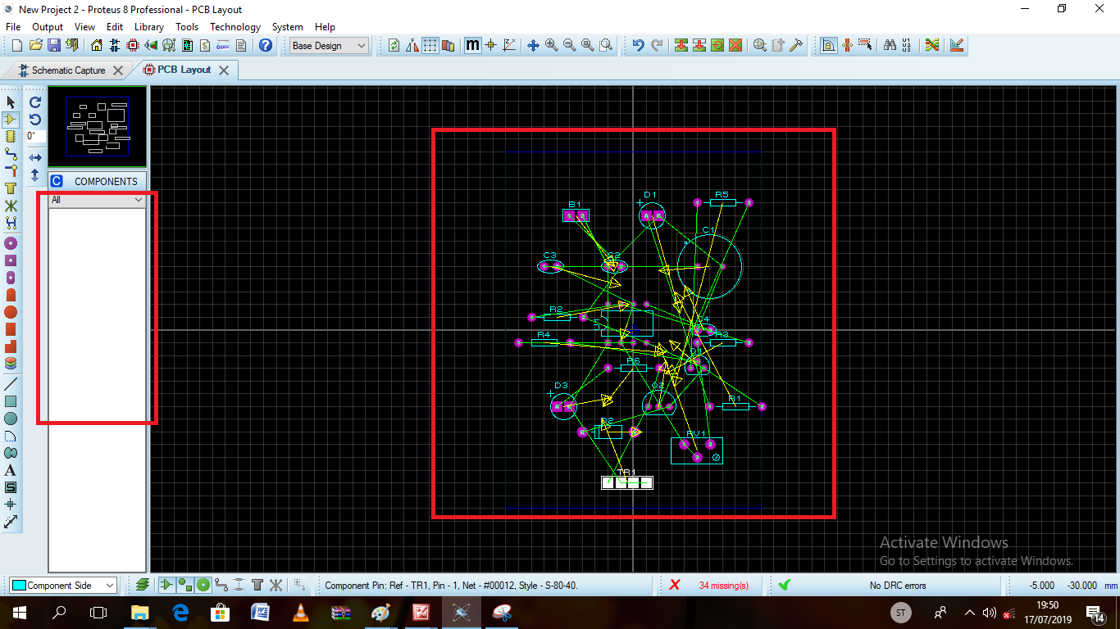

### **Routing technology**

#### **Auto Routing**

Using the auto-router is extremely simple-after all the whole point is for the computer to do the work to see it in action, start by re-loading and the invoke the auto router command from the tools menu. The default settings will do and so click OK, sit back and watch. The status display at the bottom of the screen shows what is happening and how things are going. The yellow route is one being considered for routing. The board routing will route to completion in twinkling of an eye.

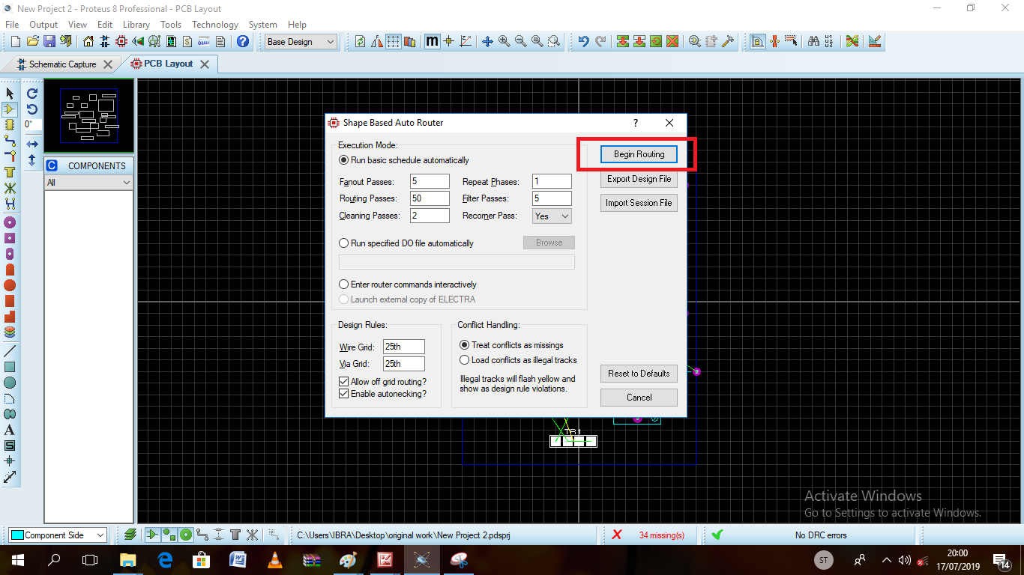

1. **Edit PCB properties**

Before we can do the routing , we edit the routing properties as per the size of our current flow and this will be seen in the proceeding screenshots.

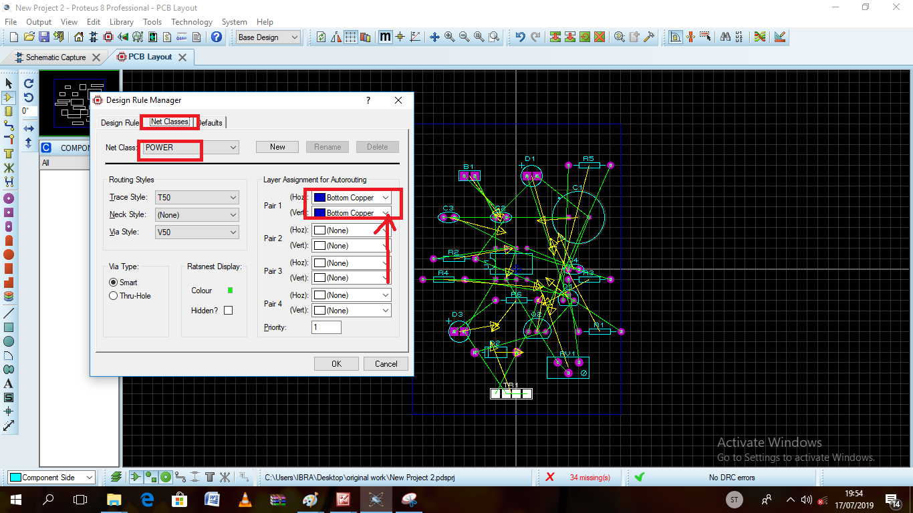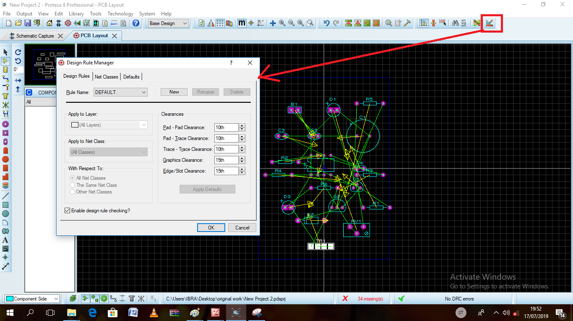

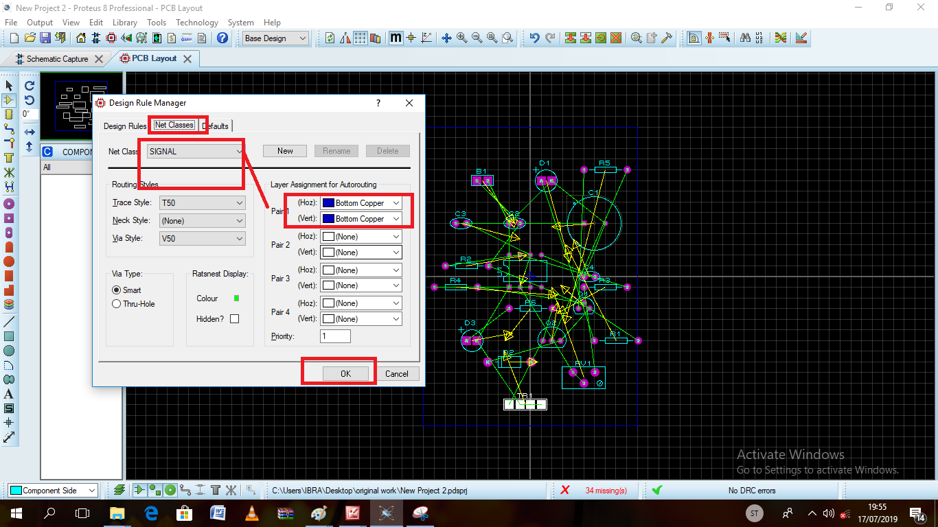

1. **Edit size of the copper route**

We can change the size of copper route from the trace style highlighted below and proceed to click okay to finish.

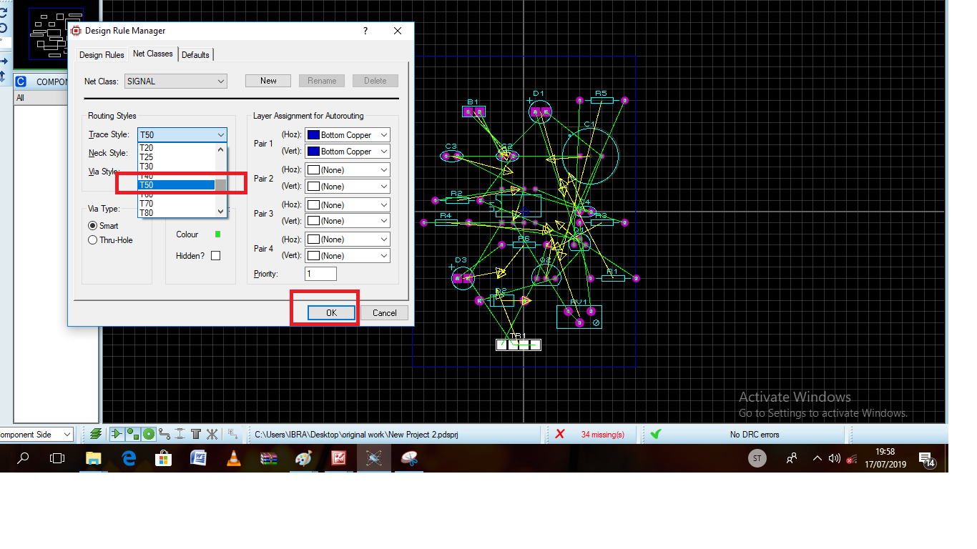

1. **Routing automatically**

We then move to the routing icon highlighted below to have our routing started.

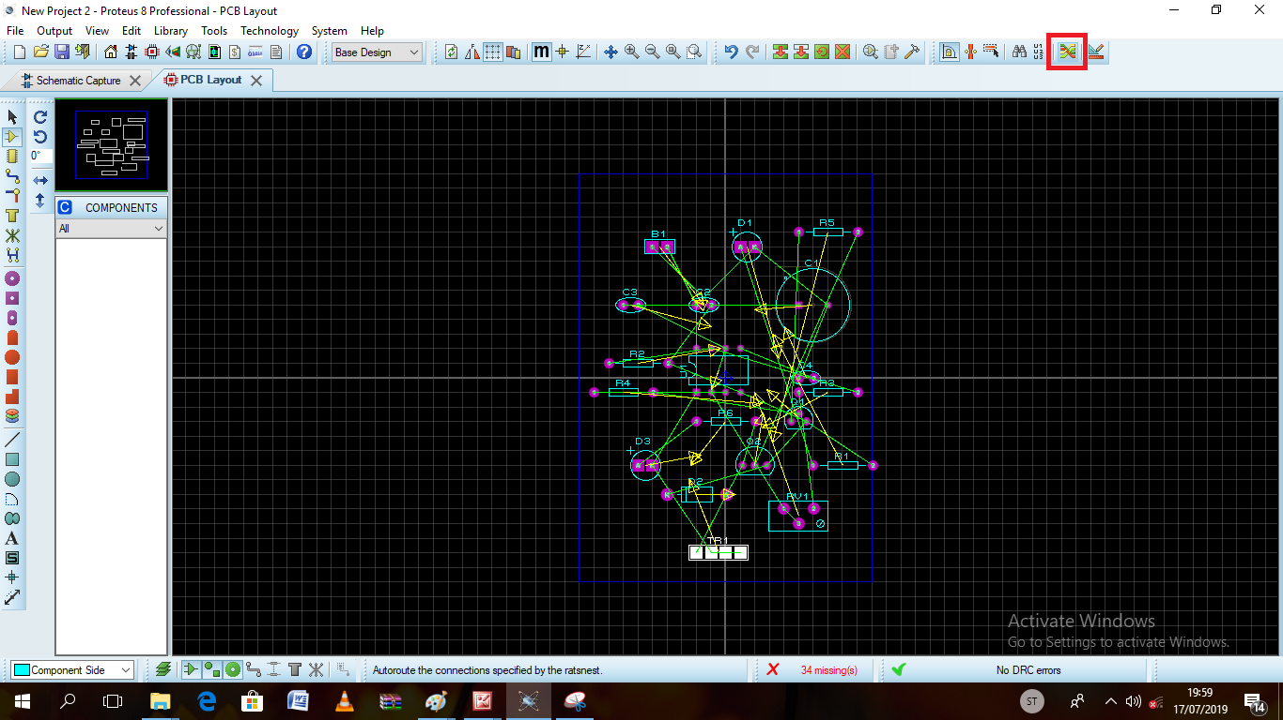

Begin the routing then by clicking on the highlighted box shown in the print screen below.



1. **Routing progress**

As the routing proceeds the screen should appear as shown below

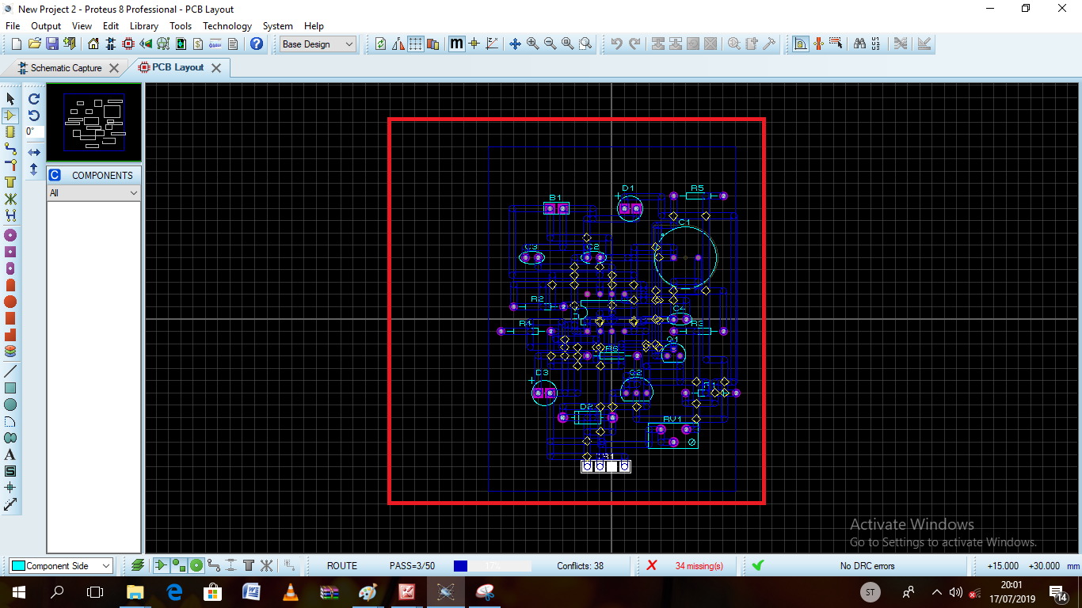

After routing

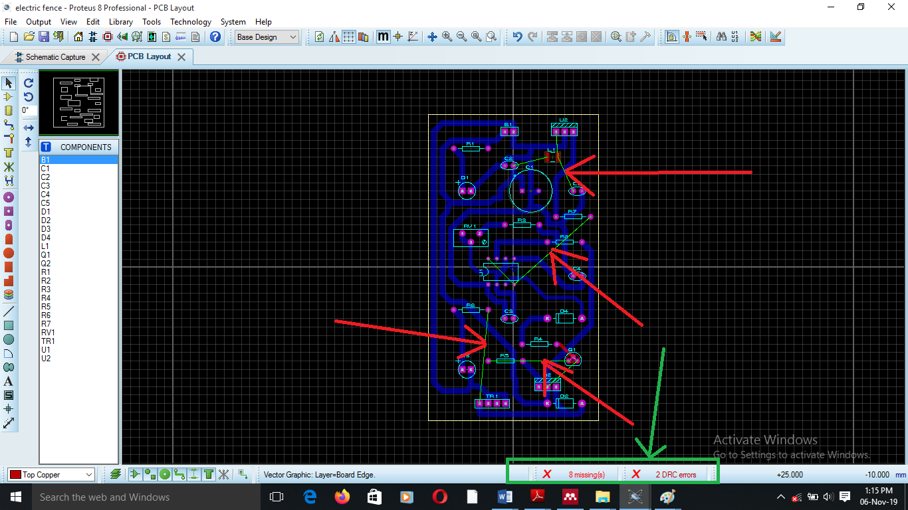

## **Report generation**

Aside from Gerber and excel on NC drill tool information, Proteus can generate two reports detailing how well the current layout meets its specification.

* Connectivity Rule Check(CRC)-checks for electrical errors(extra/missing connections)
* Design Rule Check (DRC)-checks for physical errors (overly small copper clearances)

### **Connectivity Rule Checker**

This tool establishes which pins are connected to each other by tracking and vias and compares this with which pins have been assigned to the same net in the net list. A report indicating the net groups within each net is produced and presented in a pop-up window. If you click on the items in the list, the net or nets affected by the error will be highlighted.

If you design from a netlist in the first place and especially if you use the auto-router, you are un-likely to make mistakes other than missing connections out. However, a zero errors CRC report does give confidence that your design is correct.

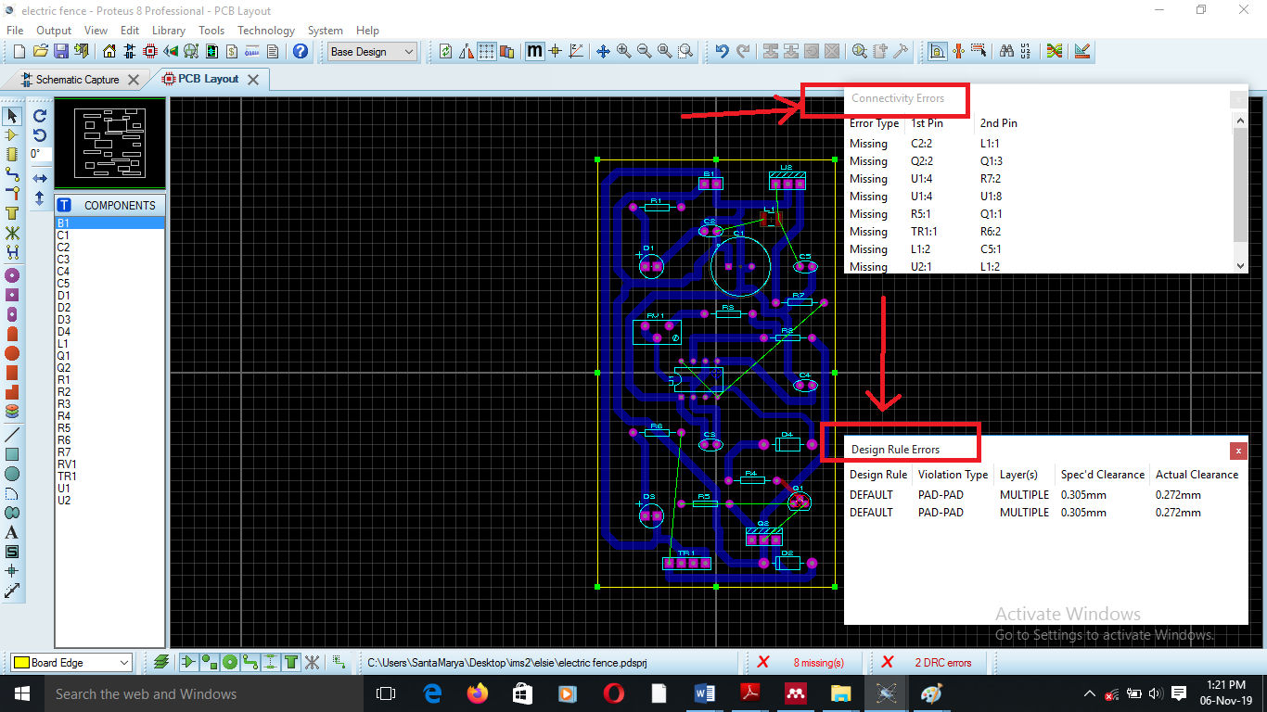

### **Design Rule Checker**

In PCB layout, design rules are pad-pad, pad-trace, and trace-trace clearance. The auto-router will of course obey the correct design rules in choosing where to place routes but the design rule checker will also verify manually placed routes are in order. Where violations occur, these are marked on the screen with a red circle and line showing which objects are too near and window appears listing all the violations that were found.

DRC errors will also be flagged if two objects are physically touching but not properly connected an example of this would be two pads which overlap but do not have a track running between them. This type of error will also show up in the CRC report as a missing connection.



1. **Routed PCB**

**To correct the DRC and CRC errors we either try to begin routing and use jumpers in red shown below**

After the routing is done the PCB layout should appear as below.

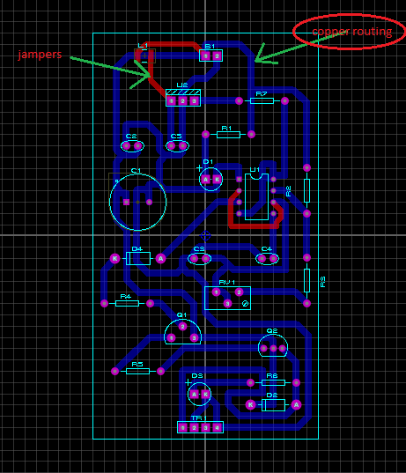

1. **3-D Visualizer of the complete circuit board**

# Click on the 3-D visualize icon shown below to have a view of the circuit board in three dimension.

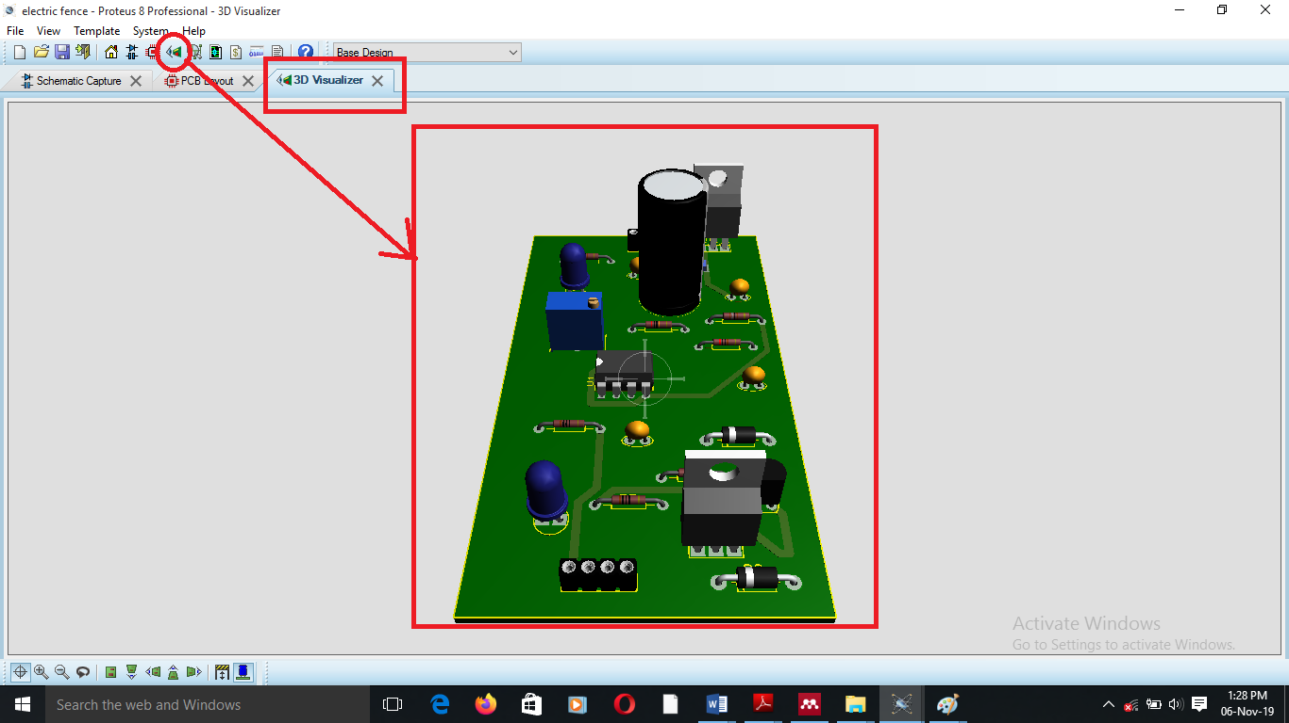

1. **3-D views**

You can flip the board to have a view of how the routings will appear on the circuit as shown below.

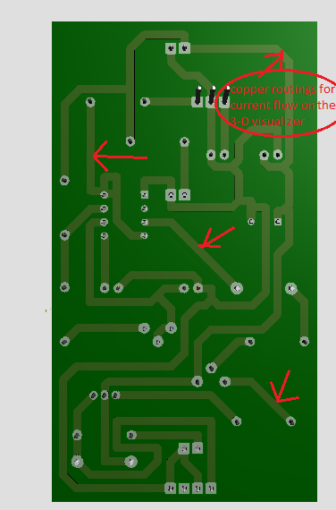

1. **3-D view of the electric fence circuit.**

